SEMI-ANNUAL PERFORMANCE REPORT

Period: April 1 – September 30, 2014

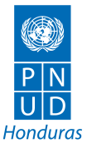
Project: “Strengthening Democratic Governance in Honduras
Through Technical Electoral Assistance and the Promotion of Citizen Security
and a Culture of Peace”

Grant: AID-522-IO-11-00001
UNDP Elections and Citizen Security

Duration: April 1, 2014 – September 30, 2015

Total Budget: USD 7,367,365.79 (Federal)
USD 1,224,654.00 (Non-Federal)

Geographic Coverage: Nationwide

October 2014

Acronyms and Abbreviations
AJH: Alianza Joven Honduras (Youth Alliance of Honduras)
AMDC: Alcaldía Municipal del Distrito Central (Municipality of the Central District ie Tegucigalpa)
AMHON: Asociación de Municipios de Honduras (Association of Honduran Municipalities)
AOP or AWP: Annual Operating Plan or Annual Work Plan
ATE Project: Asistencia Técnica Electoral (Electoral Technical Assistance) Project
AVCC: Actores Voluntarios de Convivencia Comunitaria (Community Coexistence Volunteers)
CARSI: Central America Regional Security Initiative

CEDOH: Centro de Documentación de Honduras (Documentation Center of Honduras)

CNE: Censo Nacional Electoral (National Electoral Census)
CONADEH: Comisión Nacional de Derechos Humanos (National Commission for Human Rights)
COMVIDA: Comité para la Niñez, Adolescencia y Juventud (Committee for Children, Adolescents and Youth)
CPTED: Crime Prevention Through Environmental Design

CRIC: Centro de Registro Civil e Identificación Ciudadana (Center for Civil Registration and Citizen Identification)

CSJ: Corte Suprema de Justicia (Supreme Court of Justice)
CSO: Civil Society Organization

DAE/DAP: División de Asistencia Electoral del Departamento de Asuntos Políticos (Office of Electoral Assistance of the Political Affairs Department)

DIM: Dirección de Infraestructura Mayor (Department of Major Infrastructure)

DNIC: Dirección Nacional de Investigación Criminal (National Office for Criminal Investigation)

FHIS: Fondo Hondureño de Inversión Social (Honduran Fund for Social Investment)

G-FORT: Grupo de Fortalecimiento Institucional y Transparencia (Group for Institutional Strengthening and Transparency)

GSE: Grupo de Seguimiento Electoral (Electoral Monitoring Group)

ICMA: International City/County Management Association

IDEA: Institute for Democracy and Electoral Assistance
IDECOAS: Instituto de Desarrollo Comunitario, Agua y Saneamiento (Institute for Community Development, Water and Sanitation)
INAM: Instituto Nacional de la Mujer (National Institute for Women)
INE: Instituto Nacional de Estadisticas (National Insitute of Statistics)
IPECC: Instituto de Participación y Educación Cívica y Ciudadana (Institute for Civic and Citizen Participation and Education)

ISO: International Standards Organization
IUDPAS: Instituto Universitario para la Democracia, Paz y Seguridad (University Institute for Democracy, Peace and Security)

LEOP: Ley Electoral y de Organizaciones Políticas (Law for Elections and Political Organizations)
LIBRE: Libertad y Refundación (Liberty and Refoundation)

MANUD: Marco de Apoyo del Sistema de Naciones Unidas al Desarrollo (UN’s Development Assistance Framework or UNDAF)
MER: Mesa Electoral Receptora (Polling Station)

MOE-OEA: Misión de Observación Electoral de la OEA (Electoral Observation Mission of the OAS)

MOE-UE: Misión de Observación Electoral de la Unión Europea ((Electoral Observation Mission of the European Union)
MP: Ministerio Público (Attorney General’s Office / Public Prosecutor’s Office)
NDI: National Democratic Institute
NGP: nueva gestión pública (new public administration)
NIMD: Netherlands Institute for Multi-party Democracy
OAS: Organization of American States
OMM: Oficinas Municipales de la Mujer (Municipal Offices for Women)
PAC: Partido Anti-Corupción (Anti-Corruption Party)
PCC: Puntos de Convivencia Comunitaria (Community Coexistence Places)
PEC: Proyectos de Ejecución Comunitaria (Community-Implemented Projects)
PLCySC: Plan Local de Convivencia y Seguridad Ciudadana (Local Plan for Coexistence and Citizen Security)
RCM: Registro Civil Municipal (Municipal Civil Registry)
RIO: Red para la Incripción Opertuna (Network for Timely Registration)
RNP: Registro Nacional de las Personas (National Registry of Persons)
SEPLAN: Secretaría de Planificación (Planning Ministry)
SPS: San Pedro Sula

TDRs: Términos de Referencia (Terms of Reference)
TSE: Tribunal Supremo Electoral (Supreme Electoral Court)
UMC: Unidades de Mediación y Conciliación (Mediation and Reconciliation Units)
UNAH: Universidad Nacional Autónoma de Honduras (National Autonomous University of Honduras)
UNDAF: United Nations Development Assistance Framework (Marco de Asistencia de las Naciones Unidas para el Desarrollo or MANUD)
UNDP: United Nations Development Programme
UNFPA: United National Population Fund
USAID: United States Agency for International Development

COMPONENT 1: ELECTORAL TECHNICAL ASSISTANCE

1. EXECUTIVE SUMMARY

During the period covered by this report, April to September 2014, two important events occurred affecting the implementation of UNDP’s Asistencia Técnica Electoral (Electoral Technical Assistance or ATE) Project: (1) the swearing in of the TSE’s new Board of Magistrates and (2) the approval of the Project’s continuation by the Tribunal Supremo Electoral (Supreme Electoral Court or TSE).

The election of the TSE’s new magistrates in December by the outgoing Congress and the subsequent swearing in of the new magistrates in May 2014 caused a good degree of concern in the political sector and in society in general. Although the election was originally scheduled for May 2014 and should have been made by the new Congress, it was instead moved forward and made by the outgoing Congress. Not only did the election of the magistrates take place earlier than scheduled, but the entire composition of the TSE’s Board of Magistrates remained the same, even though the November 2013 elections had brought about such a radical change in the political landscape.

The general public opinion is that the TSE has again become a partisan institution looking out for the interests of the traditional political parties, that it is moving away from the intention of the 2004 reforms that sought to de-politicize the institution and away from the multi-party reality that took shape in the 2013 elections when the traditional two party system was disrupted by the emergence of two significant political forces – the LIBRE Party and the Anti-Corruption Party (PAC). At the same time, the election of the new director of the RNP (Registro Nacional de las Personas or National Registry of Persons) has affected the Project’s activities, especially those related to strengthening the National Electoral Census (Censo Nacional Electoral or CNE), since the TSE and the RNP work so closely to create the CNE.

In the face of this situation, LIBRE and PAC demanded representation in both the TSE and the RNP, given that these are the main government bodies ensuring transparency in the electoral process. However, the complaints of these parties were ignored by Congress as a whole, further contributing to that institution’s political polarization.

The way in which the new TSE’s new magistrates were elected obviously has larger implications. In particular, the legitimacy of the 2017 electoral process can be questioned based on the perception that the TSE is no longer an impartial institution and is biased towards the traditional political parties. The legitimacy of the TSE’s composition could lead to a questioning of the election results, especially if it is a close race.

It is also important to note that following the election of the new magistrates, considered illegitimate by many sectors, the TSE’s Board of Magistrates lost credibility given that two magistrates resigned from the Board for different reasons, leaving the TSE with just one magistrate in charge. This situation, combined with the public and political distrust that the TSE faces with both the political parties and electorate, is one of the main challenges for the institution.

In spite of these issues (or perhaps because of them), the TSE agreed to begin the process of promoting the electoral reforms included in the legislative bill sent to Congress in 2011. Unfortunately, however, the political-electoral crisis in San Luis municipality, in Comayagua Department, consumed the TSE, as resolving the conflict became the institution’s top priority.

The TSE faced a difficult challenge in managing the results of the mayoral election in San Luis. The lack of decision-making capacity combined with the institution’s empowerment as the sole regulator of electoral issues demonstrated the TSE’s fragility when the dispute between mayoral candidates was finally resolved by the Supreme Court (Corte Suprema de Justicia or CSJ).

Although this solution had serious repercussions for the TSE, such as the loss of the credibility and the institutional capacity to resolve conflicts, it also allowed the TSE to focus again on the issue of electoral reform. With this in mind, the TSE, UNDP/Honduras, and USAID/Honduras, as well as UNDP headquarters in New York, all recognized the need for an impact evaluation of the technical assistance that the TSE has received over the past few years, while considering a possible extension of the Project. This evaluation, preceded by a review of lessons learned and recommendations about the approach of the technical assistance and then carried out by the needs assessment mission, had direct financial implications on the ATE Project given that concrete activities with the TSE could not be implemented without the approval of the Project’s continuation by the Office of Electoral Assistance of the UNDP’s Political Affairs Department (División de Asistencia Electoral del Departamento de Asuntos Políticos or DAE/DPA), which required a formal request for extension from the TSE. The impact assessment took place in April 2014, followed by the TSE’s extension request and a subsequent needs assessment mission in June.

Once notified of the approval of the Project’s continuation, the Project Board approved the Annual Operating Plan (AOP) for the remaining months of 2014 and the first quarter of 2015. This AOP does not have significant changes as it follows the same action lines discussed in previous meetings with USAID and is based on the recommendations of the needs assessment mission. Overall, the AOP responds to the TSE’s requests for assistance regarding (1) support for electoral reform, (2) training for the TSE’s Board of Magistrates and department heads, and (3) strengthening of the operating units, especially the Department for Training and Civic Education. As soon as the AOP was approved, the process of contracting the required consultants began.

The dynamic of electoral assistance to the TSE and strengthening the country’s democratic system could change drastically with the arrival of two important issues in the political-electoral arena – presidential re-election and an electoral runoff. Although the two issues can be considered diametrically opposed, either or both could influence the discussion and approval of possible electoral reforms based on the 2011 bill, and could also have an impact on the institutionality of the TSE, which could be especially affected by the idea of presidential continuity (ie infinite presidential re-election). Therefore, it is important to stay up-to-date on the political discussions of these issues, especially given that the change in the political scene from a two-party to a multi-party system could generate tensions, which, in the worst case scenario, could lead to a new political crisis.

2. IMPLEMENTATION OF ACTIVITIES

2.1 INDICATOR PERFORMANCE TRACKING TABLE

Output 1: Technical Assistance for the Legal and Regulatory Framework and Restructuring of the TSE’s Operating Units

Description: Development of a proposal for comprehensive legal reform of the electoral system. A comprehensive assessment of the 2012 and 2013 electoral processes. Creation of the TSE’s institutional memory report for 2009-2014. Deepening and consolidating the TSE’s organizational reform process which began in 2009, through its operating units, such as Mapping and Census, Information Technology, and Public Relations.

Indicators | Indicator performance
Matrix with comments on the various electoral reform proposals (July 2014) | Created a summary of the proposals for reforming the Law for Elections and Political Organizations (Ley Electoral y de Organizaciones Políticas or LEOP) as part of a comprehensive reform of the electoral system. Analysis was based on: (1) an analysis of the current Honduran political system based on the proposed law drafted by the TSE in 2011; (2) the main elements of the proposed LEOP reforms that have been formulated by various institutions such as the electoral observation missions of the European Union and the OAS, the Impactos Program and Caritas, the Truth Commission, CEDOH, and the TSE itself; and (3) the conclusions of the evaluation of the 2012 and 2013 electoral processes.  The matrix is still in the process of being drafted because the Project’s international technical expert had to concentrate efforts on supporting the approval of the Project’s extension. However, the importance of this analysis is evident given that it is an important input in the process of discussing a new LEOP.  This document focuses on the following reform proposals:  1. Constitutional reforms regarding: (1) the prohibition of the presidents of the judicial and legislative branches from participating in the processes for electing the president of the executive branch and (2) changing the designated vice-presidents (traditionally 3) to one elected vice-president.  2. De-politicize the TSE by choosing magistrates competitively. At the same time, members of the polling stations should be elected by lottery instead of selected by political parties.  3. Revision of the electoral system, specifically the number of representatives per department.  4. On-going updating of the electoral census by modernizing the identity cards. The delivery of the cards should be the responsibility of the TSE.  5. Making the TSE the only agency responsible for providing electoral justice remains imperative for implementing reforms to the criminal (penal) code and organizing an electoral chamber of the CSJ. It is also important to create a protocol for reporting complaints and denouncements before, during, and after the electoral process.
Proposal with articles and input from relevant stakeholders (December 2014) | Fluid communication with UN headquarters in New York in order to obtain CVs of candidates in the database of DAE/DAP to contract a legal consultant with experience in electoral reform. Various candidates have been identified and will be contacted to find out their interest and availability.  Additionally, processes were begun for contracting the ATE Project team and they are expected to start in November 2014. Once formed, this team together with the legal and electoral reform expert will work closely with the TSE and the Congressional Committee for Electoral Affairs to draft a proposal with articles and with input from all relevant stakeholders.
Congressional debates (2015) | No progress on this indicator because the Project does not yet have a team to conduct the relevant activities.  After the notification of the continuation of the Project by the DAE/DAP at the end of August and the approval of the 2014-15 AOP by the Project Board at the beginning of September, the process of contracting staff began. The team members should begin work in November 2014. Once the team is in place, the Project will have the necessary support to begin interacting with the National Congress.
Magistrates and department directors have participated in 2 regional trainings (December 2014) | No progress on this indicator because the Project does not yet have a team to conduct the relevant activities.  After the notification of the continuation of the Project by the DAE/DAP at the end of August and the approval of the 2014-15 AOP by the Project Board at the beginning of September, the process of contracting staff began. The team members should begin work in November 2014. Once the team is in place, work will begin on this indicator.
Assistance plan agreed on by the directors of the Unit for Electoral Training and Civic Education and the Gender Unit (June 2014) | In close collaboration with the staff and coordinators of the Unit for Electoral Training and Civic Education and of the Gender Unit, the ATE Project drafted a plan for activities for 2014-2015 in order to improve the coordination and implementation of activities in various areas such as research methods, organization and planning, mainstreaming democratic/civic education, training and implementation of educational campaigns, and creation and dissemination of printed and digital materials especially with mass media.  In addition, this plan will maintain focus and increase the efficiency of activities aimed at the various stakeholders, such as political parties, students and school boards, first-time voters, women, and government agencies, as well as the staff of the Unit for Electoral Training and Civic Education and of the Gender Unit.
At least 3 parties have taken actions to promote women’s participation (December 2014) | No progress on this indicator because the Project does not yet have a team to conduct the relevant activities.  After the notification of the continuation of the Project by the DAE/DAP at the end of August and the approval of the 2014-15 AOP by the Project Board at the beginning of September, the process of contracting staff began. The team members should begin work in November 2014. Once the team is in place, work will begin on this indicator.
Pilot plan to include civic education activities in a municipality (December 2014) | No progress on this indicator because the Project does not yet have a team to conduct the relevant activities.  After the notification of the continuation of the Project by the DAE/DAP at the end of August and the approval of the 2014-15 AOP by the Project Board at the beginning of September, the process of contracting staff began. The team members should begin work in November 2014. Once the team is in place, work will begin on this indicator.
Expert contracted and trained to adapt the electoral census with the RNP’s advances (July 2014) | As part of the process to strengthen the TSE’s operating units, UNDP began recruiting consultants in the areas of IT and census in order to create a platform that effectively connects the databases of the TSE and the RNP with the ultimate objective of updating the electoral census with reliable information about citizens who have the right to vote and exclude duplicate registrations, errors, deceased voters, and those voters who are ineligible to vote.  However, the consultants could not be hired by July because the process of evaluating the continuation of the Project was on-going. As of September 2014,  - International IT Consultant: the proposal with the consultancy’s terms of reference (términos de referencia or TDRs) has been prepared and is awaiting approval by the president of the TSE’s Board of Magistrates, David Matamoros. The position will be posted by the end of October.  - National Consultants in IT and Census: the consultancy’s TDRs were drafted and approved and the position was publically posted at the end of September. The hiring process should be completed in October, with the experts beginning in November 2014.
At least 3 political parties have signed a cooperation agreement with the ATE Project (August 2014) | The extensive process to approve the continuation of the ATE Project had implications on the implementation of activities to achieve this indicator. Once a team is in place, the Project will again begin working on the activities necessary to reach agreements with the political parties.
At least 2 political parties have modified or adapted their internal regulations to the electoral law (December 2014) | No progress on this indicator because the Project does not yet have a team to conduct the relevant activities.  After the notification of the continuation of the Project by the DAE/DAP at the end of August and the approval of the 2014-15 AOP by the Project Board at the beginning of September, the process of contracting staff began. The team members should begin work in November 2014. Once the team is in place, work will begin on this indicator.

OUTPUT 2: Technical Assistance to Strengthen the Training Unit and the Institute for Civic and Citizen Participation and Training (IPECC)

Description: Strengthen the TSE’s Electoral Training Unit by incorporating it into the Institute for Civic and Citizen Participation and Education (Instituto de Participación y Educación Cívica y Ciudadana or IPECC) which was created in 2011. In particular, incorporating civic, electoral, and democratic training programs, which involve representatives of the TSE and support the building of citizenship, and making use of previously designed tools, such as the “democratic values” campaign.

Indicators | Indicator performance
Memos of understanding (MOUs) signed with the Ministry of Education and at least one teacher training school (August 2014) | The extensive process to approve the continuation of the ATE Project had implications on the implementation of activities to achieve this indicator. Once a team is in place, the Project will again begin working on the activities necessary to reach agreements with the schools.
At least one institution has approved a plan for incorporating civic education (December 2014) | No progress on this indicator because the Project does not yet have a team to conduct the relevant activities.  After the notification of the continuation of the Project by the DAE/DAP at the end of August and the approval of the 2014-15 AOP by the Project Board at the beginning of September, the process of contracting staff began. The team members should begin work in November 2014. Once the team is in place, work will begin on this indicator.
Network of CSOs formed in a municipality (August 2014) | The extensive process to approve the continuation of the ATE Project had implications on the implementation of activities to achieve this indicator. Once a team is in place, the Project will again begin working on the activities necessary to reach agreements with civil society organizations.

OUTPUT 3: Maintenance of the Unit of Implementation, Monitoring and Follow-Up of the ATE Project

Description: Maintenance of the Project’s core team to coordinate horizontal cooperation for the various activities conducted by the TSE, with the goal of identifying weaknesses and opportunities for participation by international experts. The team includes an international consultant, a national technical assistant, and a financial administrator. It also includes the cost of the Project’s facilities, stationary, communications, and services necessary for the operation of the office such as electricity, water, internet, cellular phones, transportation, and security.

Indicators | Indicator performance
2014-15 AOP of the ATE Project approved by the Project Board (May 2014) | Following the August notification of the approval of the ATE Project extension, the Project Board met at the beginning of September in order to revive the Project’s activities based on the recommendations of the DAE/DAP needs assessment mission presented in July. During the meeting, board members discussed two important points: (1) the approval of the Project’s AOP for the end of 2014 and the beginning of 2015, and (2) the drafting of a revised budget based on the approved AOP.  At the meeting, the following agreements were made:  - Extension of the ATE Project until March 2015  - Approval of the 2014-15 AOP  - Approval of the expert consultancies in IT and Census  - USAID will support the process of ISO 9001 certification to manage the quality of electoral processes.  After the approval of the 2014-15 AOP, the recruitment process was intensified to form the Project team and resume Project activities. The aforementioned contracts will fill the vacancies of the international experts whose contracts ended in December 2013 as well as the vacancy of the international technical assistance expert who could not extend his contract. Recruitment processes are in the following stages:  - Principal Assistant/Coordinator: The recruitment process has begun. CVs were requested from the DAE/DAP database and a short list of qualified candidates was selected. UNDP’s acquisitions unit will contact candidates to assess their interest and availability.  - International UNV/Electoral Expert: The position’s terms of reference have been drafted and are awaiting internal review.  - National Technical Expert: The recruitment process is almost complete. A short list of three candidates has been selected based on their CVs and they have expressed their interest and availability in applying for the position. Based on the review of the evaluation committee, one of the candidates has been offered the position. It is expected that the selected candidate will join the team in November. It is important to mention that the selection of a national expert was delayed because the first two public recruitments (held in May and July 2014) were unsuccessful because of the lack of candidates with adequate experience.

2.2 PROGRESS NARRATIVE

In December 2013, the ATE Project finished its cycle of support to the TSE by providing technical assistance to manage the country’s 2013 general elections. During the first quarter of 2014, the Project concentrated on a process of transition as well as an evaluation of the accomplishments achieved during the 2012 and 2013 electoral processes. UNDP’s Coordinator for the Governance Unit and Deputy Resident Representative had a number meetings with the TSE’s Chief Magistrate, David Matamoros (the other two magistrates were absent – one for health reasons and the other resigned), and representatives of USAID. In these meetings, it was decided to continue to offer specific assistance to the TSE, in particular: (1) provide support for the electoral reform process; (2) strengthen some of the TSE’s operating units, including the re-activation of IPECC; (3) draft an institutional memory report for the TSE for the period 2009-2014; and (4) recruit international technical assistance experts.

During these meetings, UNDP officials also conveyed the request of the DAE/DAP to require an evaluation of the technical assistance provided by UNDP to the TSE over the past few years (2008-2014). The Coordinator of the Governance Unit, the Deputy Resident Representative, and DAE/DAP officials planned to conduct the assessment mission at the end of January. Unfortunately, this mission had to be postponed and was finally conducted in April 2014, when Mariela López coordinated the mission.

In addition, the Coordinator of the Governance Unit and the ATE Project’s administrative team created a revised budget for January to September 2014, which, based on the new AOP, is $822,000. The task of completing the new budget helped identify the need for consultants to implement the activities included in the AOP. Therefore UNDP formulated the terms of reference for the various consultancy positions and began recruitment processes.

In April 2014, UNDP began drafting the institutional memory report for the TSE covering the period 2009-2014, with particular emphasis on the main supports, obstacles, and lessons learned during the consolidation of democracy in Honduras. In reviewing the report, the international expert made certain observations regarding the need to improve details (eg coordination with other institutions such as the RNP and the Congressional Committee on Electoral Issues and the degree of women’s participation in politics) as well as including an assessment of political and technical analysis of key events (the political crisis of June 2009) and the actions of the TSE relevant to its operational and regulatory roles.

Also in April 2014, the ATE Project’s international expert was introduced to the TSE’s Chief Magistrate and visited the directors of the TSE’s Training and Civic Education Unit and Gender Unit to ascertain their concerns and include them in the AOP that was in the process of being drafted.

In May, the TSE’s new Board of Magistrates was sworn in for the 2014-19 term – two previously ratified magistrates, David Matamoros and Saúl Escobar, and two new magistrates, Erik Rodriguez as the third voting member and Ramiro Lobo as the substitute. This inauguration was crucial to begin concrete technical assistance activities with the TSE. ATE’s international expert visited the new TSE Board the day after the inauguration and explained the basic outline of the proposed AOP – (1) drafting a matrix of the proposed electoral reforms, (2) helping to strengthen the TSE’s operating units, and (3) training the TSE’s new Board of Magistrates and department directors.

Based on the considerations mentioned above as well as consultations with relevant stakeholders, UNDP wrote the first draft of the Project’s revised AOP, budget, and monitoring and evaluation plan. Because USAID cautioned that significant changes to the Project would make getting approval within USAID more difficult, the documents include the same products and outputs as in 2013.

It should be noted that until May 20, neither USAID, the TSE, nor UNDP/Honduras knew with certainty the new conditions that the DAE/DAP had made regarding the possibility of sending a needs assessment mission to approve the continuation of the ATE Project, which, of course, needed to be formally requested by the TSE. Therefore, UNDP contacted the relevant parties and on June 5, the TSE sent a request for an extension of technical assistance so that the DAE/DAP could continue to organize the needs assessment mission.

For the needs assessment mission, which took place from June 23-27, 2014 and was led by Horacio Boneo, the ATE Project organized meetings with key stakeholders. The first draft of the mission’s report was sent to UNDP on July 12. This document was discussed internally by the Resident Representative, Consuelo Videl; the Deputy Resident Representative; the Coordinator of the Governance Unit; and the international technical assistance expert, who made observations and recommendations and sent it back to the DAE/DPA for formal comments.

The final draft of the mission report was received by UNDP on August 19, which signified the conclusion of the process of approving the ATE Project’s continuation until December 2016. This period will be divided into two sub-periods: (1) July 2014 – March 2015, which will focus assistance on the main areas included in the AOP, and (2) April 2015 – December 2016, during which assistance will probably correspond to a revised AOP. In the latest version of the AOP presented to the needs assessment mission, the established budget is $622,000. Because the Project’s expenditures were affected by various factors, it was determined that the originally approved budget ($822,000) could not be expended on the activities planned for the corresponding period (September 2014 to March 2015).

The formal re-activation of the ATE Project took place at the beginning of September 2014 with a Project Board meeting attended by representatives of the TSE, UNDP, USAID, and the Chancellery of Honduras. During this meeting, UNDP summarized the achievements and challenges of the 2012 – 2013 electoral process and emphasized the need to continue assistance to strengthen the operating units of the TSE as well as support the process of comprehensive electoral reform based on the bill drafted by the TSE in 2010. UNDP also emphasized the importance of articulating the process of discussion and raising awareness about the electoral reform with key actors such as the Congressional Committee on Electoral Issues, the Advisory Committee of Political Parties, and civil society organizations involved in promoting democratic governance.

Meeting participants agreed to support the activities proposed in the ATE Project’s action plan and approved by the DAE/DAP, including:
(1) confirming the extension of the ATE Project and approving the AOP for October 2014 to March 2015;
(2) approving the process to hire consultants in IT and Census as detailed in Output 1, “Technical Assistance for the Legal and Regulatory Framework and Restructuring of the TSE’s Operating Units,” in order to strengthen the CNE; and
(3) USAID would allocate remaining funds in the TSE-USAID agreement to support the process of ISO 9001 certification managing the quality of the TSE’s electoral processes.

With the re-activation of the ATE Project, UNDP will begin the recruitment processes to form the Project team with the idea of resuming the main activities of the monitoring and evaluation plan in order to achieve substantial progress during the last quarter of 2014 and the first quarter of 2015.

2.3 STATUS OF ACTIVITY LEVEL LOGIC MODELS
Not applicable

2.4 IMPLEMENTATION CHALLENGES AND OPPORTUNITIES

Challenges:
- One of the main challenges concerning the process of electoral reforms has been that the members of the Congressional Committee on Electoral Issues have not been able to draft a bill reforming the LEOP due to a lack of consensus given the specific interests of the heads of each political party.

- For much of this year, the TSE’s Board of Magistrates was not complete because of the absence of two of its members – one for health reasons while the other resigned. Therefore, in spite of the Project’s constant dialogue with the Chief Magistrate, he showed little interest in issues that, from the perspective of the Project and other civil society organizations, are of paramount importance. At the same time, he did not agree with the plan that the ATE Project work with other groups except through close coordination with the TSE.

- The lengthy approval process to continue to offer technical assistance to the TSE, which included an evaluation mission and a needs assessment mission, had negative implications on the Project’s finances over the course of the year, making this a rather atypical implementation period.

Opportunities:
- After the 2013 electoral period, the Project again began activities with the TSE’s Training and Civic Education Unit with the objective of re-activating IPECC, which will contribute to the TSE’s institutional strengthening.

- After the formal approval of the continuation of the ATE Project, UNDP could begin the process of recruiting the team necessary to resume pending issues and activities included in the 2014-15 AOP.

- In contrast to the 2010-2011 process to raise awareness and discuss a potential bill on electoral reforms, the current Congressional Committee on Electoral Issues is aware of the importance of a new electoral law and is willing to make electoral reforms regarding the composition of polling stations (MERs), regulation of political campaigns, and residential updates, among others.

- The ATE Project, in recognition of its work supporting the TSE in previous elections, could again leverage its role to reach consensus among the various actors on the political-electoral scene, such as the Advisory Committee of the political parties, the Congressional Committee on Electoral Issues, civil society organizations, members of the international community, the media, and the TSE itself, and steer discussions towards a process of comprehensive electoral reform.

3. COLLABORATION AND/OR KNOWLEDGE SHARING WITH OTHER USAID ACTIVITIES
3.1 RELATIONSHIP WITH OTHER USAID ACTIVITIES
Similar to the previous semester, but with less frequency, the ATE Project had periodic meetings with the coordinators of the two other USAID-funded UNDP projects (Technical Assistance for Citizen Identification and Developing Public Policies for Citizen Security and Coexistence), representatives of USAID Democracy and Governance Office, and the Coordinator of UNDP’s Governance Unit. The two meetings in April and August 2014 focused on the progress of the projects and in the case of the ATE Project informed USAID of the approval process and the implications it would have on the Project’s implementation timeline.

3.2 KEY HIGHLIGHTS OF COLLABORATION
The presentations of the achievements of each of the USAID-funded UNDP projects (ATE, RNP, and citizen security) allow for more effective cooperation in the assistance provided to the beneficiary institutions.

3.3 CHALLENGES OF COLLABORATION
One challenge is keeping the needs of the Project within the framework of assistance internally approved by USAID. This challenge was especially evident in the process of revising the AOP and budget for 2014-25.

4. COLLABORATION AND/OR KNOWLEDGE SHARING WITH GOVERNMENT PARTNERS OR OTHER DONORS

4.1 LIST AND DISCUSS LINKS WITH RELEVANT MINISTRIES AND DONOR AGENCIES
- Despite not having the same level of involvement as last year, given that last year was an electoral year, the ATE Project participated in three meetings with the Electoral Monitoring Group (Grupo de Seguimiento Electoral or GSE) of the Transparency and Good Governance Roundtable of the G16.
1) The April 29th meeting hosted two TSE magistrates as special guests – David Matamoros and Dennis Gómez – who discussed the TSE’s management during the 2012 and 2013 elections and their perspectives on the political-electoral scene over the next five years.
2) At the May 27th meeting, the revised GSE document was presented with analysis of the political situation now that the new TSE magistrates and the RNP director were confirmed. The document also included prospects for electoral reform and the role of the international community in this process.
3) The July 8th meeting represented the first meeting with the TSE’s new Board of Magistrates during which they spoke about the precarious financial situation of the TSE and the TSE’s on-going process of re-structuring and planning.

- Furthermore, the System Monitoring Women’s Political Participation (ATENEA) represents an opportunity to coordinate actions among UNDP, UN Women, and International IDEA (Institute for Democracy and Electoral Assistance) in order to promote women’s political participation. Therefore, UNDP, through the ATE Project, has begun the process of hiring an expert in gender issues to strengthen the TSE’s Gender Unit and work closely with the inter-agency committee of ATENEA.

- The general policy of UNDP’s Governance Office is to promote dialogue with and participation of civil society. For this reason, and taking into consideration the recommendations made by DAE/DAP about strengthening the participation of civil society organizations on issues related to democratic governance, the ATE Project has facilitated discussions and presentations about electoral issues with the Grupo de Dialogo de Ciudadanía Activa (an informal group of civil society organizations).

- Finally, a multi-institutional initiative between UNDP, NIMD (Netherlands Institute for Multi-party Democracy), and the National Democratic Institute (NDI) has begun to formulate ideas for joint training workshops for actors involved in the electoral process based on five major themes: (1) financing of political parties, transparency, and accountability; (2) defining the functional structure of the TSE; (3) the relationship between the quality of representation and the electoral system; (4) the role of various actors in the electoral process and citizenship building; and (5) the political party system and its relationship with the TSE and other electoral bodies. The organization of these workshops, with the initial support of the ATE Project, is currently taking place. Nevertheless, the collaboration has been suspended until further notice because of the process of revising the ATE Project’s AOP.

5. SPECIAL REPORTING REQUIREMENTS (USAID FORWARD, PRESIDENTIAL INITIATIVE)
Not applicable

6. INTEGRATION OF CROSS-CUTTING VARIABLES

6.1 GENDER
The ATE Project decided to implement the regional initiative, the System Monitoring Women’s Political Participation (ATENEA), promoted by UNDP, UN Women, and IDEA International, in Honduras with the objective of generating reliable information and conducting a comprehensive assessment of the exercise of women’s political rights in the country. To accomplish this, the ATE Project has begun preparations to hire a gender expert.

6.2 ENVIRONMENTAL COMPLIANCE
Not applicable

6.3 GLOBAL CLIMATE CHANGE
Not applicable

7. ADMINISTRATIVE AND MANAGEMENT ISSUES

7.1 CONSTRAINTS AND CRITICAL ISSUES
The need for the approval of the continuation of electoral technical assistance to the TSE by the DAE/DPA was the most important issue of the past six months. The process began with an impact evaluation study in April 2014 and was followed by a needs assessment mission in June. The June mission produced a report and official authorization for the continuation was finally granted in August. The process culminated with the approval of the 2014-15 AOP by the Project Board at the beginning of September 2014.

After the meeting of the Project Board, UNDP re-activated the recruitment of various experts to form the new ATE Project team. The need for these experts had been explained and justified in the work plans and the consultancies will be in effect from October 2014 to March 2015.

However, the process of recruiting an international technical expert was not affected, and Mr. Jorge Guzmán was hired in April 2014. Therefore, in his capacity as head technical advisor of the ATE Project, he was in charge of the various actions required to manage the Project’s continuation, with the assistance of the Coordinator of UNDP’s Governance Unit. Unfortunately, Mr. Guzmán could not continue in this position because he also received a pension from the UN Pension Fund. This issue prevented the extension of his contract beyond August, after a months-long process to determine whether or not he could continue working under UNDP policies.

This situation obviously caused a reduction in the financial performance of the period. Nevertheless, the major areas of work continued and will be extended until 2015, with the necessary funds available for the Project’s activities as well as for the team that will implement these activities.

7.2 PERSONNEL
As part of the process to strengthen the TSE’s operating units, UNDP began a recruitment process to hire experts in the areas of IT, Census and Mapping, Gender Equality, and Training. The status of these recruitment processes is as follows:

- International Consultant and National Consultants in Information Technology (IT): The process is in progress and UNDP expects that by the end of October or beginning of November 2014 the ATE Project will begin activities to connect the databases of the RNP and TSE to strengthen the process of obtaining information for the National Electoral Census (CNE).

- Consultant in Gender Equality: As part of the TSE’s mandate to encourage women’s political participation and following the recommendations of the DAE/DAP, UNDP drafted the terms of reference to hire expert on gender equality issues. UNDP expects the consultant to start at the beginning of November 2014.

- Training and Education Consultant: UNDP advertised for a consultant in late September and expects that the position will be filled by the beginning of November 2014. The primary activities of the consultant will be: (1) to strengthen the teams of the Training Unit and IPECC in electoral issues and training and civic education, and (2) to develop civic electoral and democracy training programs that support the building of citizenship and promote a democratic culture.

Additionally, after the approval of the ATE Project’s 2014-15 AOP, UNDP intensified the recruitment process to form a team (senior advisor/coordinator, electoral technical assistant, and national technical assistant) and resumed the activities in the Project’s work plan. These contracts will fill the positions of the international experts whose contracts ended in December 2013 as well as that of the international technical advisor who was not able to extend his contract. The following chart details the status of the recruitment processes for the new ATE Project team:

Type of Consultant | Status | Period
Expert to Draft the TSE’s Institutional Memory 2009-2014 | Completed | March – May 2014
Evaluation Specialist to assess electoral technical assistance to the TSE from 2007-2013 | Completed | April – May 2014
International Technical Advisor/Coordinator | In process | October 2014 – March 2015
Elections Expert | In process | October 2014 – March 2015
National Technical Assistant | In process | October 2014 – March 2015
Training/Education Expert | In process | October 2014 – March 2015
IT and Census Technicians/Programmers to work with RNP | In process | October 2014 – March 2015
Gender Expert – ATENEA | In process | October 2014 – March 2015

7.3 CHANGES TO ACTIVITIES
Keeping in mind the time limitations to implement the Project’s activities, there is the possibility that the AOP 2014-15 will need to be revised.

7.4 MODIFICATIONS AND AMENDMENTS
The delays caused by the process of approving the Project’s continuation and the uncertainties of the time necessary to recruit qualified personnel could lead to incompletion of the Project activities. Therefore, UNDP suggests that the AOP be reviewed at the beginning of 2015 in order to adjust it as necessary.

8. EVALUATIONS AND LESSONS LEARNED

8.1 LESSONS LEARNED AND BEST PRACTICES
Over the past year, the ATE Project experienced an atypical situation given that, for various reasons, implementation of activities was extremely limited. Considering that recruitment processes began at the end of September, it is expected that the remaining funds will be expended over the next five months.

In order to avoid interruptions in the implementation of the Project and the assistance provided to the TSE, it is important to have better planning of the Project’s time periods, including the contracting of staff.

8.2 ACTIONS AND NEXT STEPS
As soon as the ATE Project’s team is formed, UNDP can define a strategy to discuss electoral reforms, including the 2011 reform bill and avoiding certain controversial issues, which may be raised by other actors. Included in the 2014-15 AOP is a series of workshops and seminars for all relevant actors in the political and electoral spheres, such as political parties, civil society organizations, and the National Congress, in order to facilitate meaningful and comprehensive discussion about electoral reforms. Another point to consider is the willingness and interest expressed by the Congressional Committee on Electoral Issues to tackle these reforms, which, importantly, represents one less obstacle in the process of implementing reform.

Beginning in January 2015, the ATE team will draft an extension request to continue the program until June 2015. This request will be sent to USAID. Following that, the ATE team will prepare another request to send to USAID with the idea of managing the Project’s financing until December 2016, if approved by DAE/DAP.

9. ACTIVITIES PLANNED FOR THE NEXT SEMESTER

Planned Activities from previous semester  (April – Sept 2014) | Current Status (September 2014) | Explanation for Changes | Proposed Activities for the next semester  (Oct 2014 – March 2015)
Technical Assistance to Reform the Legal/Regulatory Framework and Restructure the TSE’s Operating Units | UNDP synthesized the electoral reforms to the LEOP that will serve as an important input to the matrix commenting on the various reform proposals.  UNDP is awaiting the final version of the TSE’s 2009-2014 institutional memory report which the consultant should submit in November.  UNDP has begun the process of hiring consultants in electoral reform, gender issues, IT, and census in order to begin implementing Project activities scheduled for the next 5 months.  To provide support to the TSE’s Training and Gender Units, UNDP has developed an assistance plan together with the directors of each unit based on their goals. | Many of the activities included in the AOP could not be implemented because they required the approval of the Project’s continuation and then the recruitment of consultants and the development of a revised budget. | - Support for Electoral Reform  - Develop a matrix commenting on the various reform proposals  - Review the electoral reform bill presented by the TSE with support from UNDP  - Internal discussion about the revised electoral reform proposal  - Draft the bill’s articles  - Support the Congressional debates on the bill  - Create a mechanism for coordination between the TSE and the Congressional Committee on Electoral Issues  - Workshops, seminars, and forums on electoral reform with civil society organizations, the National Congress, and electoral officials  - Consultations and citizen education about the content of the electoral reform, in collaboration with civil society organizations  - Training on the electoral law for media  - Support to Strengthen the TSE’s Operating Units  - Technical assistance to draft the TSE’s 2009-2014 Institutional Memory report  - Support for training the TSE’s new magistrates and directors  - Support for the Census and Mapping Unit: hire experts to link the TSE and the RNP  - Creation of a Monitoring and Follow-up Unit (Executive Office)  - Provide assistance to the Gender Unit  - Support the adjustment of the gender requirements of the political party law: statutes, offices, etc.
Technical Assistance to Strengthen the TSE’s Training Unit and the Institute for Citizen and Civic Participation and Education (Instituto de Participación y Educación Cívica y Ciudadana or IPECC) | The amount of strengthening of the Training Unit and IPECC was minimal. UNDP held talks with the Unit’s coordinator and staff to include their concerns in the revised AOP. | The activities could not be conducted due to the process of approving the Project’s continuation. | - Support to Student Governments. Civic and Democratic Education. Creation of a Citizens’ Network.  - Support to the 2014 Student Governments, University Elections, and the Ministry of Education’s campaign for civic information  - Coordination with the Ministry of Education about the including civic education in the curriculum  - Coordination with teaching colleges about including democracy and citizenship training in the curriculum  - Pilot experience with a Citizens’ Network  - Training on non-sexist reporting for the TSE  - Agreement among TSE, UNDP & the Ministry of Education for democratic training campaigns  - Evaluation and selection of consultants for the TSE’s Training Unit/IPECC  - Support for the TSE’s Democratic Values campaign  - Training of trainers in the Citizen Participation division  - Education certificates in democracy and electoral law
Maintaining the Unit on Implementation, Monitoring and Follow-Up of the ATE Project | The Project’s AOP was not approved until September 5th, after the notification of the approval of the Project’s continuation by DAE/DAP. Therefore hiring for the Project’s team is in progress. | The process of approving the Project’s continuation affected the process of the approval of the AOP. | - Functioning of the ATE Project’s Office  - Drafting of the team’s terms of reference  - Hiring of experts and consultants  - Implementation of activities in accordance with the AOP  - Monitoring, follow-up, and reporting about the Project’s achievements  - Effective and timely administrative management of the Project

10. FINANCIAL INFORMATION
Budget:

 | Original grant (September 30, 2011) | Modification 1  (July 9, 2012) | Modification 4 (October 31, 2013) | Total
Federal | $300,000.00 | $500,000.00 | $1,500,000.00 | $2,300,000.00
Non-Federal | $130,000.00 | $150,000.00 | $162,386.24 | $442,386.24
Total | $430,000.00 | $650,000.00 | $1,662,386.24 | $2,742,386.24

10.1 FINANCIAL STATUS AS OF SEPTEMBER 30, 2014
Award | 00050266
Output | 00062007
Component | 1
Name: | Tecnical Electoral Assistance
Federal Cash
a. Cash Receipts | $2,300,000.00
b. Cash Disbursements | $1,597,505.28
c. Cash on Hand (line a minus b) | $702,494.72
Federal Expenditures and Unobligated Balance:
d. Total Federal funds authorized | $2,300,000.00
e. Federal share of expenditures | $1,597,505.28
f. Federal share of unliquidated obligations | $29,216.84
g. Total Federal share (sum of lines e and f) | $1,626,722.12
h. Unobligated balance of Federal funds (line d minus g) | $673,277.88
Recipient Share:
i. Total recipient share required | $442,386.24
j. Recipient share of expenditures | $524,300.76
k. Remaining recipient share to be provided (line i minus j) | -$81,914.52

11. BRANDING, COMMUNICATION AND DISSEMINATION
Not applicable

12. SUSTAINABILITY AND EXIT STRATEGY
Since the beginning of the ATE Project, the main focus of the TSE has been strengthening its Training Unit. For that reason, as part of the institutional strengthening component, in this post-electoral period, the ATE Project has targeted its efforts on recruitment via public competition and training qualified staff to conduct activities in this area with efficiency and professionalism, as well as to replicate the trainings in other electoral entities such as the Departmental Electoral Courts (Tribunal Electoral Departmental or TED), the Municipal Electoral Courts (Tribunal Electoral Municipal or TEM), and electoral offices. Therefore, UNDP will continue to build staff capacity and conduct workshops, seminars, and meetings focused on developing the necessary skills to achieve sustainability in the actions undertaken by the TSE.

13. ANNEXES
Not applicable for this period.

COMPONENT 2: TECHNICAL ASSISTANCE IN CITIZEN IDENTIFICATION

1. EXECUTIVE SUMMARY

INTRODUCTION
Citizen identification and civil registration are key to the realization of human rights, the strengthening of democracy, and the development and security of a country. Identification expressed as the right to a name and a nationality is the basis for citizenship, which in turn is the essence of democracy. Similarly, a timely, reliable, secure, and transparent civil registry is a fundamental input not only for the development and maintenance of a reliable electoral census, but also for the design of inclusive public policies aimed at strengthening democratic governance by reducing poverty, promoting development, and improving security. These are public goods that a democratic State should not, under any circumstances, postpone. For this reason, UNDP, with the support of USAID, has agreed to support the RNP through a project to strengthen its capacities.

The work of government institutions, civil society, and donors, united by a commitment to advance the process of democratization in this country, has made possible the encouraging results described in this report and serves an example of the optimization of resources, in the context of efficient and transparent public administration.

RESULTS OBTAINED
Improving Security and Transparency in Honduran Identification
During this period, April to September 2014, the UNDP Project, “Improving the Management of the RNP (Registro Nacional de las Personas or National Registry of Persons)” has continued working on the activities initiated during the previous periods. Once the November 2013 national elections were over, UNDP’s efforts focused on reducing under-registration of civil events – certificates for births, deaths, marriages, and divorces. Beyond voter registration and electoral implications, the maintaining an updated civil registry is important for the development of public policies and citizen security. Every government needs to have reliable information about who its citizens are and where and how they are living.

To improve the registration of civil events in Honduras, UNDP has taken a two-pronged approach – (1) reducing the time that the registration process takes within the RNP itself and (2) expanding access for citizens. To achieve this latter goal, UNDP signed cooperative agreements and began working closely with other government institutions, such as the Public Prosecutor’s Office (Ministerio Público), the Ministry of Health, and UNAH. In particular, with UNDP’s assistance, the RNP is in the process of installing Centers for Civil Registration and Citizen Identification (Centros de Registro Civil e Identificación Ciudadana or CRICs) at UNAH, as well as morgues and hospitals. The CRICs will be small, auxiliary offices of the RNP and will provide citizens with documents such as birth certificates, death certificates, marriage licenses, as well as register requests for identity documents. This effort is extremely important because it allows specific groups, such as students or those using public hospitals, to quickly and readily access the services of the RNP. Additionally, by decentralizing the RNP’s services and making them more accessible to certain groups, the establishment of these satellite offices also benefits the citizenry as a whole because it reduces the workload and waiting time for these services at the RNP’s main office. Finally, the decentralization of registration services also helps encourage a culture of registration among key demographics of the population, such as young people, who make up the majority of citizens. By also providing these services in the morgue, the RNP, with UNDP’s help, hopes to improve the under-registration of deaths, which according to UNDP’s assessment, is attributable to various reasons including a general culture of not registering deaths and the accessibility of registration services as well as general poverty and exclusion. By decentralizing the RNP’s services and making them more accessible, UNDP and the RNP hope to promote a new, more effective culture of registration by improving the services and capacity of the RNP as well as encouraging civil registration among specific populations.

Strengthening the Management of Primary Inputs for the National Electoral Census
During this period, UNDP created a pilot plan for the assessment of the under-registration of deaths in order to establish the methodology and obtain information currently held by the institutions which record citizen deaths at the municipal level, including hospitals, municipalities, cemeteries, morgues, and funeral homes. The assessment will cover the country’s 25 largest cities.

Additionally, UNDP has been working on a pilot project to create and compare databases between the Medical Examiner’s Office and the RNP. As part of this project, UNDP project staff digitized (photographed and uploaded) 500 collection and autopsy records. The project also aims to raise awareness among the officials of the Medical Examiner’s Office and the RNP about the procedures to register deaths as described in the manuals and systems of the Medical Examiner’s Office.

Improving the Application Process and Delivery of Citizens’ Identification Cards
UNDP has created a document describing and systematizing the results obtained from the distribution of citizens’ identity cards and the actions undertaken by the RNP’s Group for Institutional Strengthening and Transparency (Grupo de Fortalecimiento y Transparencia de RNP or G-FORT). Additionally, UNDP and the RNP are drafting of a book with recommendations for registration and identification activities.

Strengthening the Capacity of the National Registry of Persons (RNP)
UNDP assisted the RNP in drafting its Report to the Nation, which summarized the results obtained during the course of this project. The outgoing RNP authorities then presented the Report to other government officials, international donor organizations, representatives of other Central American civil registries, and the public in general. UNDP coordinated the participation of the municipal civil registries of El Salvador and Guatemala in this event and took the opportunity to organize a meeting of the Inter-institutional Technical Group of Central American Civil Registries.

PROBLEMS ENCOUNTERED
Problem 1:
The change of authorities at the RNP has delayed implementation of various Project activities. For example, workshops with G-FORT were not held and planned acquisitions were not finalized because members of the RNP’s new purchasing committee have not yet been formally appointed.

Actions Taken:
UNDP met with the RNP’s new authorities to discuss the Project and obtain their support.

Problem 2:
The lack of timely approval of the 2014 Annual Work Plan created a disconnect between the implementation of the Project and the achievement of desired results.

Actions Taken:
UNDP is conducting as many activities as possible, according to what has already been planned, such as implementing various communications mechanisms and following up to facilitate the process of signing agreements.

LESSONS LEARNED
1. When creating working plans during periods when authorities are changing, it should be taken into consideration that there will be a period of transition, which will cause delays in implementation. Therefore it is important to raise awareness about the project with the new authorities in order to begin implementing it as soon as possible. Given that there will always be some resistance to change within an institution, in the case of the new RNP authorities, the on-going participation and approval of the new practice of distributing identity cards directly to citizens has been crucial to achieve the Project’s objectives.

2. In order for the Project to be implemented as designed, it is necessary to improve the speed with which funds are approved.

3. Successes or Best Practices: Considering the importance of identification processes, especially in the current context of political and social polarization, a best practice is the opening of institutions and processes to citizen control and oversight. This practice ensures transparency with which comes legitimacy. At the same time, it constitutes a significant support in achieving better institutional performance through on-going assistance for new procedures.

The concentration of services has always been one of the most challenging problems of public administration. Therefore this experience of decentralizing registration services can serve as an interesting case study in public administration for other government institutions.

4. Recommendations: Greater community involvement through organized and existing grassroots structures and state institutions with a local presence could encourage ownership of the processes by the citizenry and ensure sustainability beyond specific time periods.

Regarding on-going challenges, it is important to continue working to encourage non-partisanship in (or to de-partisan) the processes and the institution itself. This is critical to advance the legitimacy that institutions such as the RNP require in order to fulfill their mandates in an efficient, effective, and transparent manner.

Finally, monitoring and evaluation in a timely and systematic way is important not only to continuously improve the Project but also so that partner organizations and Honduran society in general is aware of and values the Project’s impact.

2. IMPLEMENTATION OF ACTIVITIES

2.1 INDICATOR PERFORMANCE TRACKING TABLE

Output 1: Security and Transparency in Honduran Identification
Indicators | Indicator performance
Number of Centers for Civil Registration and Citizen Identification (CRICs) installed and functioning in the Medical Examiners’ Offices (morgues), hospitals, and universities. | The construction of the CRICs has been awarded to a company.  Construction has begun on the CRICs in the morgues in Tegucigalpa and San Pedro Sula.  In the process of establishing the places and agreements for installation of the CRICs at UNAH campuses in Tegucigalpa and San Pedro Sula.

Output 2: Strengthening of Management of Primary Input for the National Electoral Census
Indicators | Indicator performance
Number of deaths identified in the places visited while conducting an assessment of the under-registration of deaths in the country. | 500 collection and autopsy records were digitized (photographed and uploaded) in the Medical Examiner’s Office as part of a pilot project to create and compare databases between the Medical Examiner’s Office and the RNP.  Conducted a pilot study tour to assess deaths recorded in 25 Municipal Civil Registries.

Output 4: Strengthening the Capacity of the RNP
Indicators | Indicator performance
Number of people that attended the Central American Event on Civil Registration and Citizen Identification and the Presentation of the National Report by the Honduran RNP. | 300 people attended the Report to the Nation by the Honduran RNP.

2.2 PROGRESS NARRATIVE

Output 1: Security and Transparency in Honduran Identification

- The RNP has increased its security levels from 8% to 45% according to the standards of the International Standards Organization (ISO), thus safeguarding the data of all Honduran citizens. The RNP is able to project to the public a new image of quality and trust in civil identification services to counteract the public perception of distrust and insecurity in its performance.

- During this period, UNDP has confirmed the contractors for the construction of the CRICs and has begun building them as well as purchasing the necessary equipment for them. Overall, the CRICs will expand the services provided by the RNP and will establish procedures and install equipment that will encourage connections between the RNP and the Public Prosecutor’s Office, specifically the Medical Examiner’s Office.

- In order to certify the RNP’s new Security Management Information System, UNDP has researched Latin American businesses that specialize in ISO 27000 certification, which certifies the security of information (eg information technology, security techniques, information security management systems, requirements).

- Because of UNDP’s assistance through this project, the RNP has been able to count on having the support necessary to continue improving the level of information security in both the main and decentralized offices.

Output 2: Strengthening the Management of Primary Inputs for the National Electoral Census

- Based on the manuals and systems of the Medical Examiners’ Office, UNDP drafted a document describing the procedures necessary for registering deaths.

- UNDP supported the creation and dissemination of a cooperative agreement between the RNP and the Public Prosecutor’s Office for the timely registration of deaths. This agreement will allow the development of an up-to-date database of deaths in order to provide the Tribunal Supremo Electoral (Supreme Electoral Court or TSE) the information necessary to create the National Electoral Census (Censo Nacional Electoral or CNE).

- With UNDP’s assistance, the RNP now has the methodology, tools, and procedures to digitize (photograph and upload) the collection and autopsy records of the Medical Examiners’ Office. As part of a pilot project for the creation and comparison of databases of the RNP and the Medical Examiners’ Office, UNDP project staff has digitized 500 collection and autopsy records.

- Through a field study to implement a pilot project to assess information about the sub-registration of deaths around the country, UNDP helped the RNP learn about the procedures for registering deaths used by funeral homes, hospitals, cemeteries, municipalities, and the RNP in the country’s 25 largest cities.

- Additionally, as a result of the pilot field study for the assessment of the under-registration of deaths, the RNP now has a matrix comparing the geographical and environmental aspects (security, road conditions, accessibility of the institutions visited) of each municipality, created by the project teams and the RNP. This matrix will be important for planning future visits of RNP brigades to the field to register citizens or distribute identity cards.

- UNDP also developed a document detailing the information flow regarding deaths, which the RNP can use to create laws and regulations to improve the information flow and thus improve the registration of deaths around the country.

Output 3: Improve the Processes of Applying for and Delivery of Identity Cards to Citizens

a) UNDP drafted a document detailing the Project’s best practices with regards to the delivery of identity cards, which will help the RNP establish successful new processes to improve the services the agency provides to citizens.

b) Additionally, thanks to this Project, the RNP now has a document focused on improving the knowledge and processes of civil registrations. Originally entitled “150 Registration Practices,” after presenting it to various high-level RNP officials, it is now called “Recommended Practices in Registration Processes and Citizen Identification,” and UNDP believes that it will improve the quality of the RNP’s customer service.

Output 4: Strengthening the Capacity of the RNP

a) Through this Project, UNDP provided logistical and technical support to the RNP in the creation of the institution’s Report to the Nation and for the event to present the report to the public.

b) With support from this Project, the RNP is now a member of the Regional Committee of National Registries of Persons, which also includes the national registries of persons of El Salvador and Guatemala. This committee facilitates the exchange of experiences between countries and bridges the gaps that there are between these neighboring countries.

c) In May 2014, in conjunction with the RNP’s Report to the Nation, UNDP organized a meeting of the Regional Committee of National Registries of Persons. The civil registries of El Salvador, Guatemala, and Honduras used the opportunity to demonstrate the projects that they are implementing, share information, and discuss possible topics for joint study.

d) For the meeting of the Regional Committee of National Registries of Persons, UNDP and the RNP drafted a concept paper entitled “Central American Coastal Areas Free from Under-registration,” which focuses on reducing the indices of under-registration in the coasts of Central America. This initiative has been raised by the RNP in the Regional Committee for Civil Registries as a possible joint project.

e) Following the change of authorities at the RNP, UNDP established mechanisms to inform and raise awareness about the Project’s accomplishments among the agency’s new officials.

2.3 STATUS OF ACTIVITY LEVEL LOGIC MODELS

Flow chart of the Strategy for Implementing the Plan to Reduce the Under-registration of Deaths

Stage 1

Identify and establish cooperative agreements between relevant institutions and the RNP

Stage 3

Creation of Registration Promoters and a Promotional Campaign

Stage 2

Collection and Analysis of Information
Assessment of the Under-registration of Deaths

Scanning and digitalization of Information
Creation of the institutions’ databases
Comparison of the databases
Creation of a document about the assessment of the indices of under-registration of deaths
Etapa IV

Mobilization of the RNP Brigades

Publicity Campaign

Action by the Mobile Brigades

2.4 IMPLEMENTATION CHALLENGES AND OPPORTUNITIES
The largest and most complex challenges facing the weak Honduran institutions are related to reducing partisan influence on them. Progress towards transparency and efficiency in public administration depends in large part on the hiring of directors and staff that are more responsive to good performance criteria rather than political party affiliation. In the case of the RNP, whose functions are critical to the credibility of electoral processes, the claim of non-partisanship is even greater in a context of significant changes in the national scene, specifically the profound crisis that led to the emergence of new political forces that put an end to the traditional two-party system which had been in place for more than a century. Citizens’ demand for changes is loud and forceful, presenting an opportunity for decision-makers, with the support of international donors and civil society, to undertake the changes necessary to improve the country’s public management, democracy, and development.

3. COLLABORATION AND/OR KNOWLEDGE SHARING WITH OTHER USAID ACTIVITIES

3.1 LIST LINKAGES WITH OTHER USAID ACTIVITIES
The openness and political will on the part of the RNP officials to receive support, assistance, and social oversight from an external group composed of civil society organizations and state institutions concerned with defending human rights as well as international donors is an unprecedented experience in the country. This experience could provide significant knowledge for other institutions and areas of public administration in which the citizenry is demanding a new style of public management based on transparency and efficiency in its processes and results.

3.2 KEY HIGHLIGHTS OF THE COLLABORATION
Openness to the participation of new actors, transparency, and accountability on the part of public institutions historically questioned for their poor performance.

3.3 CHALLENGES OF THE COLLABORATION
An on-going challenge in public institutions is to make sure that the collaboration generates synergies that allow for improved performance and credibility as well as the sustainability of the processes. This experience has accomplished that goal, demonstrating that it is possible to overcome excessive bureaucracy, turf issues, and lack of compromise to get to a new style of public administration that promotes transparency and continuous improvement in performance.

4. COLLABORATION AND/OR KNOWLEDGE SHARING WITH PARTER ENTITIES IN HOST GOVERNMENT AND OTHER DONOR AGENCIES

4.1 LIST AND DISCUSS LINKS WITH RELEVANT MINISTRIES AND DONOR AGENCIES
Since 2008, UNDP has worked with the Honduran government on various initiatives related to strengthening democratic governance and respect for human rights. In 2012, USAID joined forces with UNDP to support the strengthening of the country’s democratic governance through technical assistance for the 2012-2013 election cycle. The project focused on institutional strengthening of the TSE and the RNP, the latter through technical assistance for citizen identification. To accomplish these profound changes, the project designed a comprehensive and incremental approach that focuses on the efficiency and optimization of resources along with creating conditions for improved transparency and credibility, while ensuring continuity and sustainability in the medium and long term. It is a multi-dimensional approach that includes:
- modernization of services and offices;
- personal, interpersonal, and mass communications strategies;
- expansion, facilitation, and personalization of accessibility to services offered by the RNP;
- incorporation of new and diverse members of government, civil society, and donor organizations interested in transparency and accountability in institutional performance and service-delivery;
- development of technical, managerial, and accountability capacities in the RNP, within the framework of a new results-oriented management model (“new public administration” or “nueva gestión pública” or NGP); and
- promotion of an inclusive and participatory culture of registration from a human rights perspective.

Therefore, strengthening the RNP’s performance is seen as way of promoting the country’s development and democratization.

5. SPECIAL REPORTING REQUIREMENTS (USAID forward, presidential initiative)
Not Applicable

6. INTEGRATION OF CROSS-CUTTING ISSUES

6.1 GENDER
Not applicable for this reporting period

6.2. ENVIRONMENTAL COMPLIANCE
Not Applicable

6.3 GLOBAL CLIMATE CHANGE
Not Applicable

7. MANAGEMENT AND ADMINISTRATIVE ISSUES

7.1 CONSTRAINTS AND CRITICAL ISSUES
Problem 1:
Delays in the implementation of the Project, given that the Annual Operating Plan was not approved until June 2014.
Actions taken:
UNDP conducted activities that did not require large budget expenditures.

Problem 2:
Changes in RNP authorities has generated a delay in some of the Project activities, such as the workshops with the Group for Institutional Strengthening and Transparency (G-FORT).
Actions taken:
UNDP met with the new RNP authorities to present and discuss the Project and obtain their support for it.

7.2 PERSONNEL
Not applicable for this reporting period

7.3 CHANGES TO ACTIVITIES
Not applicable for this reporting period

7.4 MODIFICATIONS AND AMENDMENTS
Not applicable for this reporting period

8. ASSESSMENTS/EVALUATIONS/LESSONS LEARNED

  - LIST MAJOR ASSESSMENTS/INTERNAL EVALUATIONS AND LESSONS LEARNED
Lessons Learned
    - When the government is in transition, with new officials coming in and others leaving, there will be delays in the implementation of Project activities and this should be considered when creating annual operating plans. It is also important to discuss the project with incoming officials so that activities can resume as soon as possible.

    - It is important to speed up the paperwork required for approving funds so that project activities can be implemented according to what is planned.

8.2 ACTIONS AND NEXT STEPS
During the next period, the Project will give sustainability and continuity to the processes initiated, with the goal that the RNP offers an effective and efficient service to the country’s citizens. This challenge has two complimentary dimensions: to strengthen the RNP and to update of the census. Therefore the Project proposes the following goals:

- Continue training the RNP’s technical staff on issues related to IT security.
- Install 4 Centers for Civil Registration and Citizen Identification (CRICs) – in the 2 morgues and 2 at UNAH campuses in Tegucigalpa and San Pedro Sula.
- Conduct an analysis of the deceased who appear on the 2013 National Electoral Census (voter registration rolls).
- Conduct an assessment of the under-registration of deceased in the country.
- Support the RNP’s re-engineering process with the creation of at least 4 process and procedures manuals, including the reform of the law and regulations governing the RNP.

9. ACTIVITIES PLANNED FOR NEXT SEMESTER

Planned Activities from previous semester  (April – Sept 2014) | Current Status (September 2014) | Explanation for Changes | Proposed Activities for the next semester  (Oct 2014 – March 2015)
4 Workshops on IT Security | Not conducted | Reprogrammed for November 2014 because the RNP’s technical staff was involved in computerizing the Municipal Civil Registries and were not able to attend | 6 Workshops on IT Security
Visits to the Municipal Civil Registries to conduct a national assessment on the under-registration of deceased | Conducted a pilot field study in 25 Municipal Civil Registries to create a national-level assessment about the under-registration of deceased | To establish the methodology to be used in the national level assessment | Visit the 250 remaining Municipal Civil Registries to conduct the national assessment of the under-registration of deceased
Create a database of deceased for the Medical Examiners’ Office in order to update the RNP’s database | Working on the creation of this database | Delay in receiving the necessary information because the Medical Examiners’ Office is unifying the various formats used | Creation of a database of deceased for the Medical Examiner’s Office in order to update the RNP’s database of eligible voters
Installation of the Centers for Civil Registration and Citizen Identification (CRICs) the morgue and UNAH in Tegucigalpa | Awarded the contracts for construction of the CRICs | Construction of the CRIC in Tegucigalpa’s morgue will begin in October 2014 | Installation of CRICs in the morgue and UNAH in Tegucigalpa
Conduct an analysis of the deceased voters that were included in the 2013 National Electoral Census | In progress | Relevant data will be obtained through the assessment of under-registration of deceased | Conduct an analysis of the deceased voters that were included in the 2013 National Electoral Census
8 workshops with G-FORT | Not held | Changes of officials at the RNP and other relevant institutions | Have requested to reprogram this activity

Acquisition of 1 vehicle | Not purchased | Problems with institutional regulations | Have requested to reprogram this activity
Connect 34 Municipal Civil Registries to the main RNP server | Not connected by UNDP | RNP connected the municipal civil registries with its own funds | Have requested to reprogram this activity
Present the RNP’s Report to the Nation | 300 people attended the presentation of the RNP’s Report to the Nation

10. FINANCIAL INFORMATION

Budget:
 | Original grant (September 30, 2011) | Modification 1 (July 9, 2012) | Modification 4 (October 31, 2013) | Total
Federal | N/A | $500,000.00 | $1,500,000.00 | $2,000,000.00
Non-Federal | N/A | $155,000.00 | $121,411.76 | $276,411.76
Total | N/A | $655,000.00 | $1,621,411.76 | $2,276,411.76

  - FINANCIAL STATUS AS OF SEPTEMBER 30, 20144
Award | 00057767
Output | 00083476
Component | 2
Name: | Technical Assistance and Citizen Identification
Federal Cash
a. Cash Receipts | $2000,000.00
b. Cash Disbursements | $1640,838.11
c. Cash on Hand (line a minus b) | $359,161.89
Federal Expenditures and Unobligated Balance:
d. Total Federal funds authorized | $2000,000.00
e. Federal share of expenditures | $1640,838.11
f. Federal share of unliquidated obligations | $71,503.78
g. Total Federal share (sum of lines e and f) | $1712,341.89
h. Unobligated balance of Federal funds (line d minus g) | $287,658.11
Recipient Share:
i. Total recipient share required | $276,411.76
j. Recipient share of expenditures | $443,486.19
k. Remaining recipient share to be provided (line i minus j) | -$167,074.43

11. BRANDING, COMMUNICATIONS & DISSEMINATION

11.1 KEY COMMUNICATIONS ACTIVITIES – specific activities that reflect branding awareness for USAID
All the documents drafted for the Project mention that funding is provided by USAID.

11.2 BRANDING
To date, the Project has not been able to obtain the necessary authorizations to use the USAID logo on documents and promotional material developed by the Project.

12. SUSTAINABILITY AND EXIT STRATEGY
Supporting the participation of the Transparency Roundtable and the Institutional Strengthening Group (G-FORT) as external actors in the institutional strengthening process is notable for two reasons – (1) the political will and openness of the RNP to open itself to a participatory process with civil society, donors, and other government agencies and (2) the commitment from civil society, donors, and other government agencies who have decided to support the changing processes in public administration. Both of these have been key factors in achieving the project’s objectives and making it replicable for other public institutions.

Another key element for the technical and political sustainability of the Project has been the negotiations with political parties. Through this cooperation, RNP has shared its new computerized processes with the political parties so they could monitor and update their internal party identification processes. Until now, the political parties had been managing their registration lists manually, which impeded efficiency in organizing their activities. With the transfer of this technology, facilitated by the Project, the political parties have the capacity to update their own voter rolls in an efficient manner.

In addition, the strengthening of human capital, equipment, and organizational infrastructure will help the citizenry view the RNP as a public institution that offers an efficient service, surrounded by honesty and legal security. This, in turn, will better position the RNP in its interaction with key stakeholders of society (political parties, citizen organizations, media) as well as its coordination with other government institutions (the Executive Branch, Health, Education, the Comptroller General’s Office, etc).

13. ANNEXES

13.1 SUCCESS STORIES
Not applicable for this reporting period

13.2 TRAINING REPORT
Not applicable for this reporting period

13.3 PICTURES (Events, Trainings, etc)

Report to the Nation “Consolidating the RNP as an Institution Strengthens Democracy in Honduras”
May 2014 – BCIE

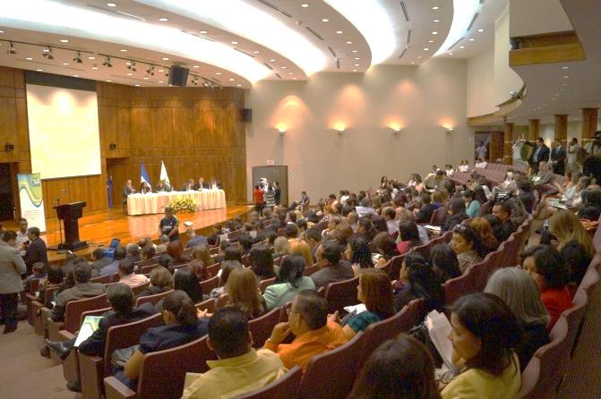
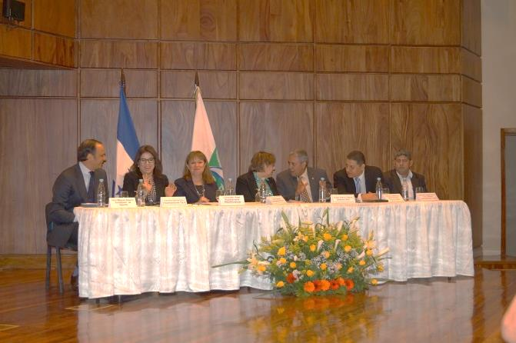

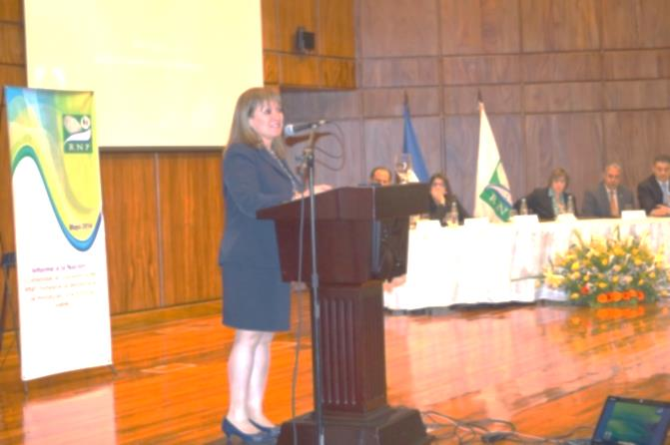
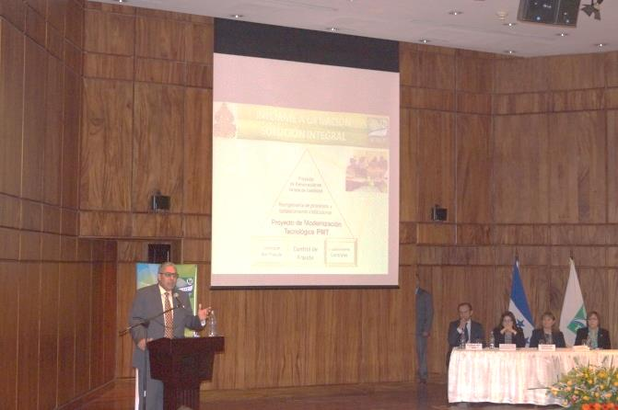
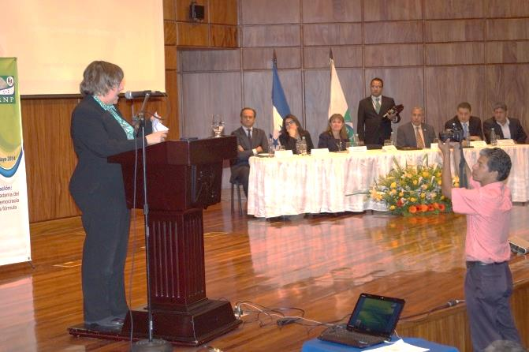
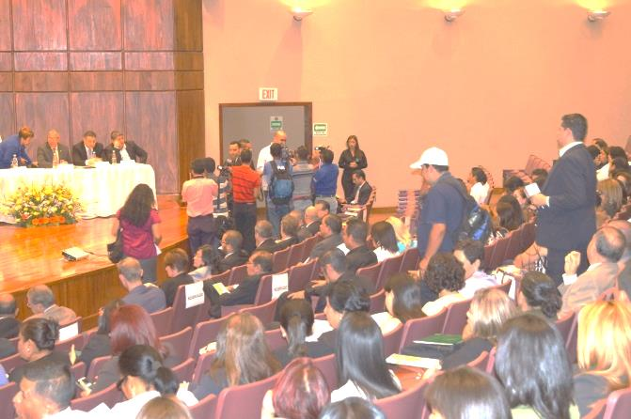
Meeting of the Inter-agency Sub-regional Technical Roundtable
of the National Registries of Persons of El Salvador, Guatemala, and Honduras
May 2014
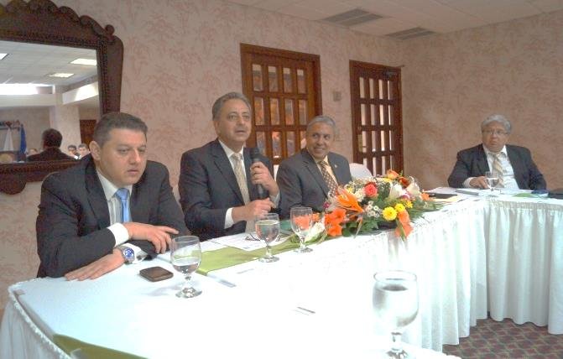
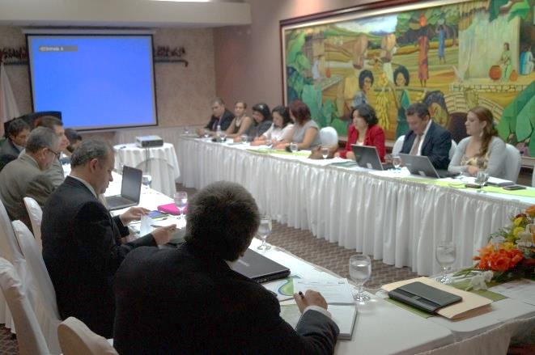

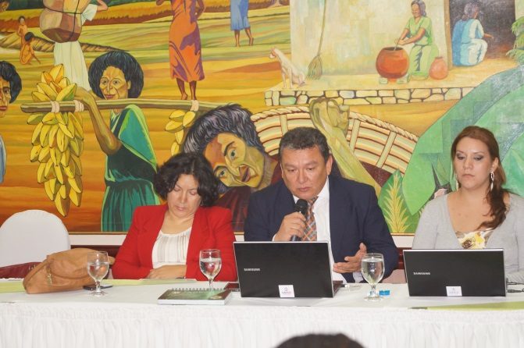
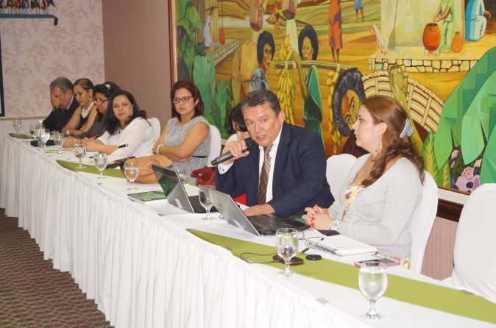

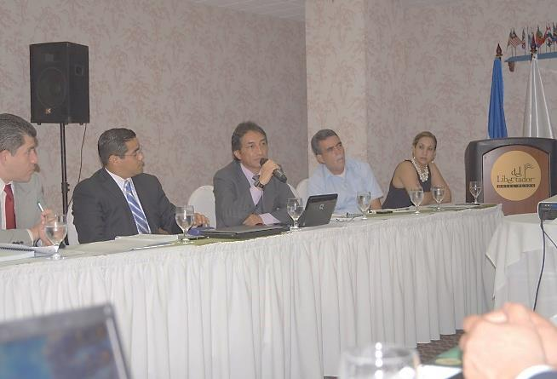
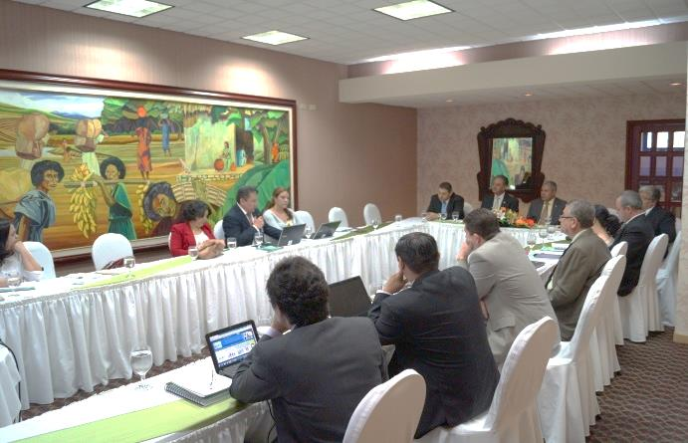
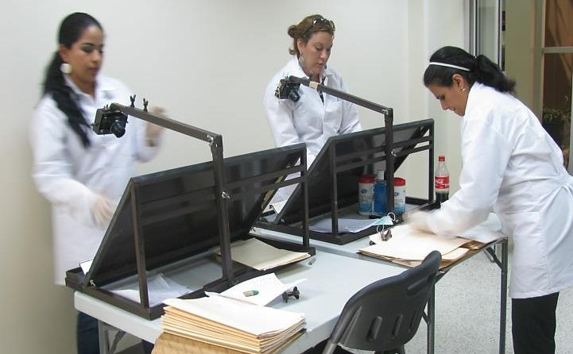
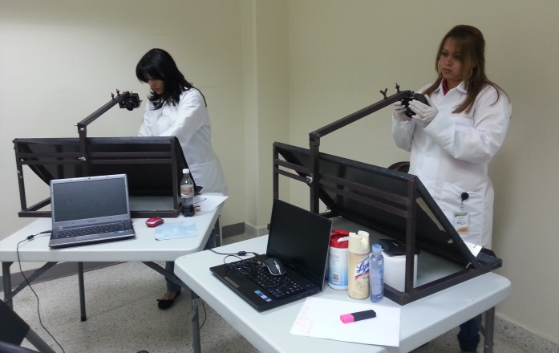
Pilot Project to Update the RNP’s Database,
based on information from 500 files from the Medical Examiners’ Office

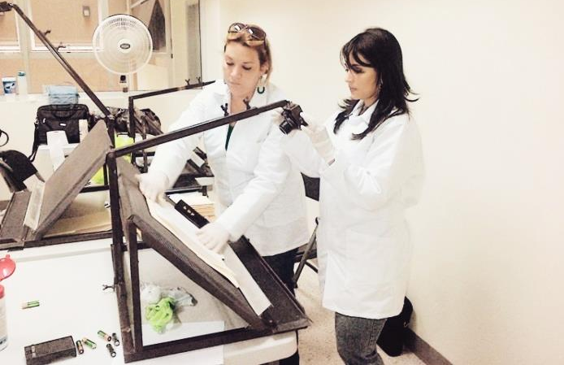
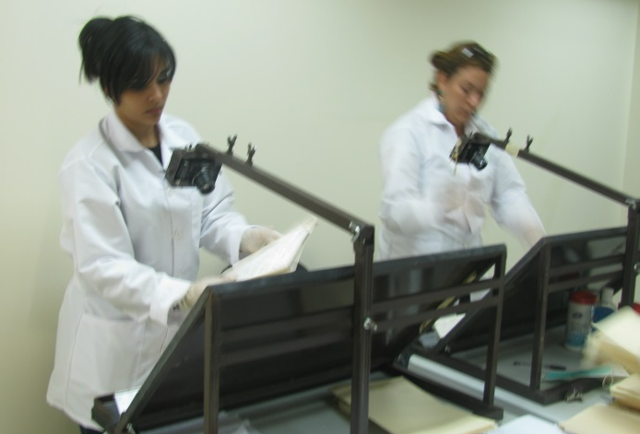

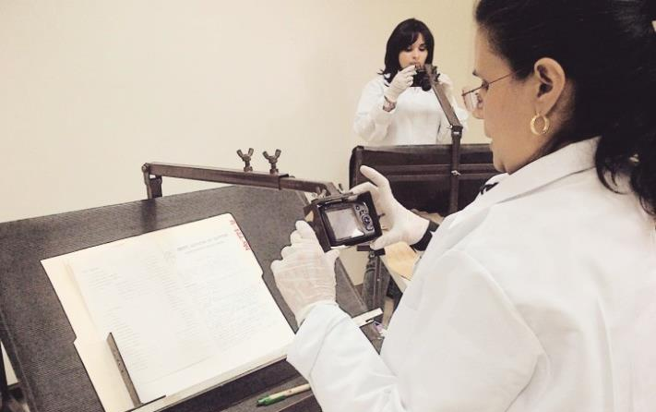
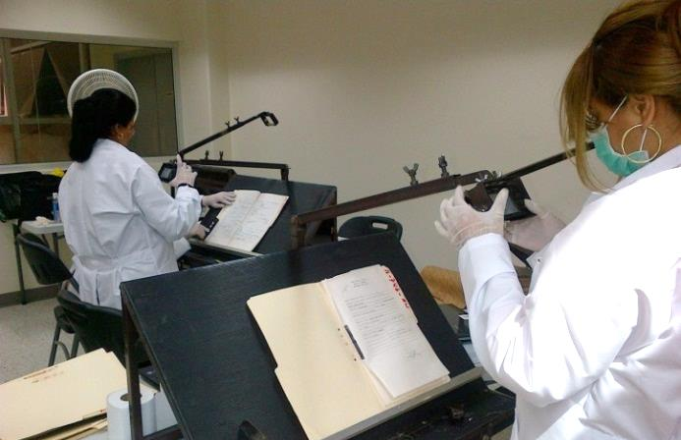
Pilot Field Study of 25 Cities
to create assessment of under-registration of deceased
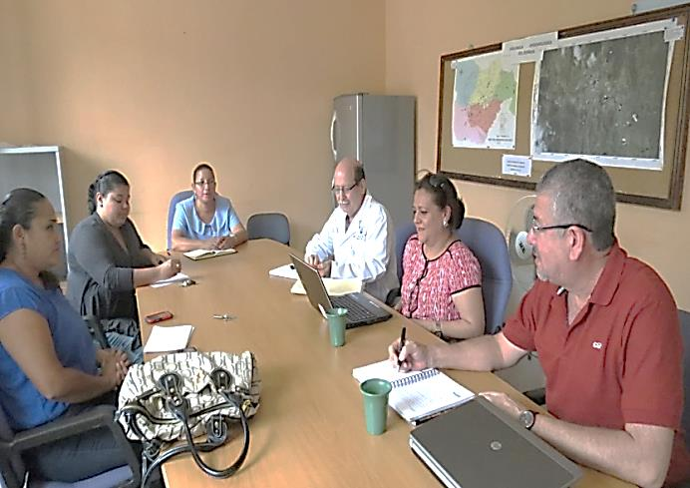

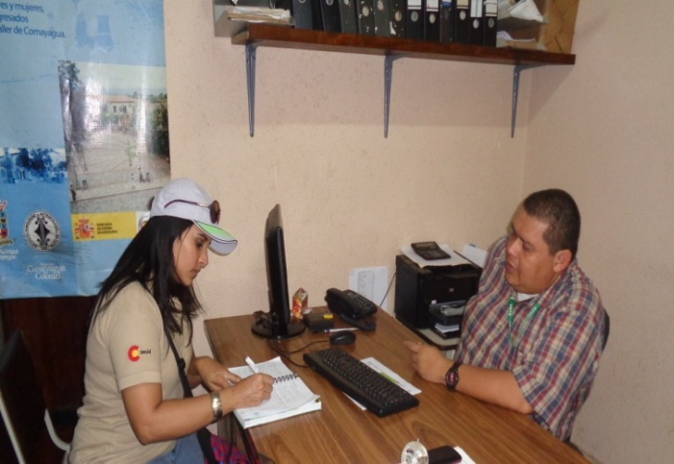
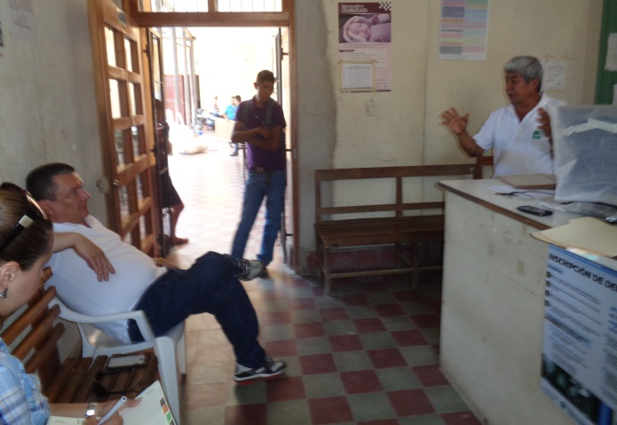
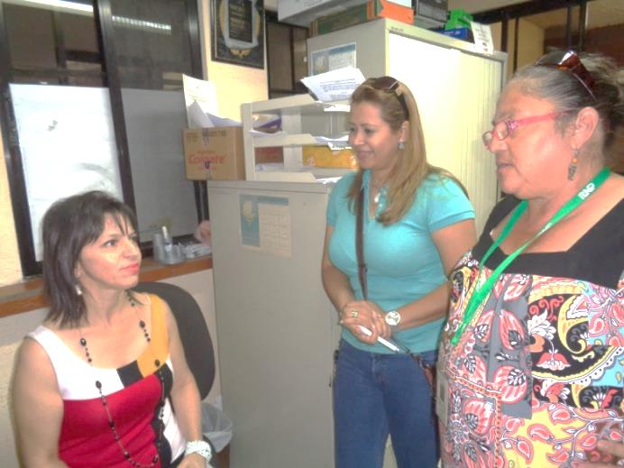
13.4 QUALITY REVIEW CHECK SHEET

Project Milestones | Scheduled Delivery Dates | Current Status
Reprogrammed Project Work Plan | November 2014 | Waiting for the Project board meeting
Project Board Meetings | November 2014 | Held in February 2014
Field Supervision | November 2014
Audit | March 2014 | In process

COMPONENT 3: DEVELOPMENT OF PUBLIC POLICIES FOR CITIZEN SECURITY AND COEXISTENCE

1. EXECUTIVE SUMMARY

Over the past six months, the Project’s most important advancement has been the implementation of the Local Plans for Coexistence and Citizen Security (Planes Locales de Convivencia y Seguridad Ciudadana or PLCySC) that were developed during the previous semester as part of the annual work plans in four of the five target municipalities: Choloma, La Ceiba, San Pedro Sula, and Tela. In the Central District, the PLCySC was created and is awaiting approval by the municipal government in order to continue the technical assistance that will allow for its certification by the Security Ministry. Improving municipal management will facilitate implementation of the actions established by the plan and its subsequent monitoring.

Because the actions included in the Annual Operating Plans (AOP) require financial resources, UNDP conducted a workshop with officials from the five municipalities to present the experiences of Choloma and La Ceiba with their financial management of the Fund for Citizens’ Protection and Security (Fondo de Protección y Seguridad Poblacional). San Pedro Sula was assigned 30 million lempiras (about $1.5 million) to implement some of the actions included in the 2013 PLCySC. La Ceiba received two disbursements from the Fund for a total of 7.2 million lempiras (about $340,000). Choloma requested about Lps 3,140,000 (about $150,000) from the Fund and also presented six projects to the Under-Secretary of Security for a total of 14 million lempiras (about $667,000). Meanwhile, Tela presented its “Equipped Beach” project to the Under-Secretary of Security for 19 million lempiras (about $900,000). To date, neither the municipal government of Choloma nor that of Tela has received a response from the national government.

At the municipal level, UNDP continued assisting the local violence observatories and developed a process to validate data from government sources (the Preventative Police, the National Office for Criminal Investigation, the Medical Examiner’s Office, and the Attorney General’s Office) which will allow for municipal data to be compared with national level data and to be published in bulletins.

As part of the project, UNDP is providing CPTED methodology training and support to the Instituto de Desarrollo Comunitario, Agua y Saneamiento (Institute for Community Development, Water and Sanitation or IDECOAS) and the Fondo Hondureño de Inversión Social (Honduran Fund for Social Investment or FHIS). In July 2014, UNDP signed an agreement of nearly Lps 1.5 million (more than $65,000) to help IDECOAS/FHIS improve its capacity to design, manage, and implement social projects using the CPTED methodology. UNDP will provide technical assistance to the CPTED Special Technical Unit and the municipal units, draft manuals and guides about this methodology, and conduct trainings so that the tools can be used by the municipalities.

Regarding the strengthening of the Mediation and Reconciliation Units (Unidades de Mediación y Conciliación or UMC) in the five target municipalities, UNDP has opened eight (8) Community Coexistence Places (Puntos de Convivencia Comunitaria or PCC) in Choloma, La Ceiba, San Pedro Sula, and Tela. Additionally, UNDP has begun training coexistence promoters and community mediators. UNDP also drafted and validated the code of ethics for the network of Community Coexistence Volunteers (Actores Voluntarios en Convivencia Comunitaria or AVCC) which established the network’s guidelines. UNDP, with input from the volunteer network and the UMCs, designed a communications campaign regarding conflict mediation and reconciliation. Finally, UNDP conducted a number of activities to strengthen and strategically position the UMCs within the municipalities, including training staff of the five UMCs; holding meetings with various municipal authorities; teaching the first module for the Certificate in Mediation and Reconciliation to municipal staff from Choloma, La Ceiba, San Pedro Sula, Tela, and Tegucigalpa as well as other relevant institutions; and conducting seminars with justice operators to raise awareness about the functions and usefulness of the UMCs.

In addition, UNDP promoted a gender focus in the PLCySCs of the five target municipalities. Importantly, UNDP created an assessment to identify the current status of violence against women, the critical path taken by women violence survivors, the responses of official institutions and civil society organizations, and the needs of the Municipal Offices for Women (Oficinas Municipales de la Mujer or OMM) to address the issue.

Regarding the Project’s culture and youth programming, UNDP has taught trainers in youth-to-youth training methodology, in alliance with programs from the Committee for Children, Adolescents and Youth (Comité para la Niñez, Adolescencia y Juventud or COMVIDA) in the five target municipalities. UNDP has also developed an entrepreneurship seminar for at-risk youth and has worked on designing a communications campaign to prevent violence and crime.

2. IMPLEMENTATION OF ACTIVITIES

2.1 INDICATOR PERFORMANCE TRACKING TABLE

Indicators | Indicator performance
Number of semi-annual bulletins published with information from the local violence observatories | At the municipal level, UNDP developed a process to validate data with government sources (Preventative Police, National Office for Criminal Investigations, Medical Examiner’s Office, and the Attorney General’s Office) which has allowed local data to be compared with national level data. UNDP had expected to publish 15 bulletins, and, to date, has printed and presented 13 bulletins in the 5 target municipalities. The data for the first six months of 2014 has been analyzed but not yet published because the data needs to be validated.  UNDP also drafted bulletins and special reports for vulnerable groups such as students and workers in the transport sector.
Number of municipal government institutions that use information generated by the violence observatories for the design and/or implementation of public policies | The five target governments are using the information on violence and insecurity gathered from UNDP’s municipal assessments, which has allowed municipal officials and security committees to learn about the situation and establish relevant strategies and local public policies.  The Security and Prevention Committees have reliable information from the validation and analysis of deaths and injuries from external causes that classify the modes of operation and the principal victims of violence.  In La Ceiba, at the request of the municipal government and the chamber of commerce, UNDP has geo-referenced the tourist sites and zones where there are property crimes.
Number of projects presented by the municipal governments for financing to the Fund for Protection and Citizen Security or other sources. | San Pedro Sula presented 2 projects and has recieved 30 million lempiras to implement actions in its 2013 PLCySC, while La Ceiba presented no projects but has received 7.2 million lempiras.  Choloma requested about 3.2 million lempiras, but has not yet received any financing from the Fund.  Additionally, Choloma and Tela responded to a request for proposals from the Under-Secretary for Security. Specifically, Choloma presented 6 projects included in its 2014 AOP for a total of 14 million lempiras. Tela presented a 19 million lempira project entitled “Equipped Beach.” To date, however, neither municipal government has received a response.

Number of operating plans that include social prevention actions, situational prevention, dissuasion, and crime control in Choloma, La Ceiba, San Pedro Sula, Tela, and the Central District. | The municipal governments of Choloma, La Ceiba, San Pedro Sula, and Tela drafted and approved Annual Operating Plans, while the Central District government included activities in these areas in the five-year PLCySC.
Percentage increase in cases that have been mediated by the UMCs and PCCs in the Project’s five target municipalities. | Over the past six months, the number of cases resolved by mediation increased by 108%, while the number resolved by reconciliation increased by 44%. The percentage of cases resolved in the PCCs was 87%.
Number of people in the five target municipalities that have received a Certificate in Mediation and Reconciliation for Community and Citizen Coexistence | 24 people are participating in the program to receive a Certificate in Mediation and Reconciliation for Community and Citizen Coexistence, from the five municipal governments, as well as from civil society, UNAH, the Association of Honduran Municipalities (Asociación de Municipios de Honduras or AMHON), and the justice of the peace in San Pedro Sula.
Number of OMM experts that  receive the “Gender, Violence against Women and Citizen Security” Certificate | The course for the Certificate is in progress and various OMM staff are participating – 2 from Choloma, 2 from La Ceiba, 2 from SPS, 2 from Tela, and 1 from Tegucigalpa.
Draft an operating manual for the 5 OMMs with emphasis on their functions to address violence | UNDP has drafted 5 operating manuals for the OMMs. The manual for Choloma has been approved by the municipal government and the others are waiting for approval from the rest of the municipalities.
Number of youth entrepreneurs working in at least 3 municipalities before the training process and provision of financing | UNDP has developed a model for opportunities management with the municipalities, chambers of commerce, and UNAH. UNDP is also in the process of signing micro-capital agreements with the municipal governments and the chambers of commerce to provide grant funds for the entrepreneurs in the 5 municipalities. UNDP will provide 300,000 lempiras (about $14,000) for each municipal fund. In addition, UNDP is training youth in Comayagua.
Number of art and civic culture intervention proposals in the five target municipalities. Strategies for civic culture formulated and implemented in the 5 target municipalities. | There are 5 proposals for intervention currently being implemented, one in each municipality. UNDP has completed the first phase of technical training in art and civic culture in the 5 municipalities, with an average of 3 workshops in at least 4 artistic disciplines.
Creation of a national group of youth trained to train youth trainers in art and a culture of peace in the 5 target municipalities. | A group of 40 youth from the 5 target municipalities have been trained as trainers in art and civic culture.

2.2 PROGRESS NARRATIVE

Local Violence Observatories strengthened and include citizen participation in the development of public policies for citizen security and coexistence.

Output 1: Strengthen the Violence Observatories in San Pedro Sula, Choloma, Tela, and La Ceiba with the inclusion of citizen participation modules and as an input for developing public policies for citizen security and coexistence.

UNDP has continued to work on the Local Violence Observatories, analyzing the information and graphs and drafting and publishing the 2013 and 2014 Bulletins for the municipalities of Choloma, La Ceiba, San Pedro Sula, and Tela. UNDP also provided equipment and data management software to the municipalities.

UNDP has created geo-referenced thematic maps with the deaths from external causes and the crime rate in both La Ceiba and Tela. In addition, UNDP has trained the coordinators and technical teams of the local violence observatories and has provided them with relevant technical advice. UNDP has also been building the capacity and coordination of actions with the mayor’s offices and municipal Security Committees in Choloma, La Ceiba, and Tela. Over the past six months, UNDP has held a number of meetings with regional authorities of the National Police and the Attorney General’s Office as well as the Ministry of Security, signing an agreement to validate data at the national level.

In the first half of 2014, UNDP produced five bulletins with the data from the local violence observatories and presented them to the Councils for Coexistence and Security. The 2013 Bulletin was presented to the municipal governments of Choloma and San Pedro Sula. To date, UNDP has produced a total of 13 bulletins. In addition, during the first six months of 2014, UNDP consistently worked on collecting, reviewing, and verifying the data from the local violence observatories with official sources such as the Regional Police and Medical Examiner’s Office. UNDP also presented the information to the Prevention Committees in the target municipalities. UNDP has trained staff, created a database, processed information, and designed a plan for analysis that will allow for better management and use of information in decision-making.

Output 2: Creation of an Observatory in the Central District

Because of the tensions between the Minister of Security and UNAH, and the creation of municipal violence observatories by the government, UNDP formed a technical unit inside the National Violence Observatory/IUDPAS (Instituto Universitario para la Democracia, Paz y Seguridad or University Institute for Democracy, Peace and Security). UNDP hopes that with the agreement with the Ministry of Security, UNAH will be able to provide technical assistance to the 30 municipal observatories that have been recently created, including the one for the Central District (Tegucigalpa).

Local Citizen Security and Coexistence Plans for the municipalities of the Central District, San Pedro Sula, Choloma, Tela, and La Ceiba

Output 3: Train Mayors, Municipal Officials, and Civil Society in Citizen Security and the Promotion of Peaceful Coexistence, including the Participation of Women

UNDP has drafted a conceptual proposal for the Certificate in “Citizen Security” to train mayors, municipal officials, and civil society, and has continued working on the “informal” training for municipal officials to build their capacity on issues such as human security, citizen security, gender violence, peaceful coexistence, violence prevention, and civic culture.

Output 4: Develop Local Citizen Security and Coexistence Plans in the Central District, with specific actions to improve the security of women.

UNDP conducted an assessment for the Central District and helped draft its Coexistence and Citizen Security Plan, which was approved by the municipal government in a town hall meeting. With the assistance of UN Women, UNDP helped incorporate a gender focus in the AOPs of the Choloma, La Ceiba, San Pedro Sula, and Tela, as well as in the PLCySC of the Central District.

Output 5: Strengthen the capacity of FHIS (Fondo Hondureño de Inversión or Honduran Fund for Social Investment) to design, manage, and implement social infrastructure projects using the CPTED methodology and facilitate knowledge transfer to officials and other municipal stakeholders.

Together with DIM-FHIS (Dirección de Infraestructura Mayor / Fondo Hondureño de Inversión Social or Department of Major Infrastructure / Honduran Fund for Social Investment), UNDP created a work plan to strengthen institutional capacities. Additionally, in July 2014, UNDP and IDECOAS negotiated and signed a technical assistance agreement which provides for the transfer of financial resources, studies of administrative capacity, recruitment of technical experts, and development of materials and training workshops to promote the use of CPTED and PEC (Proyectos de Ejecución Comunitaria or Community-Implemented Projects) methodologies as well as a university certificate in CPTED. (See Output 6 for more details.)

Output 6: Training for mayors, government officials, and community leaders in CPTED and PEC methodologies, in collaboration with FHIS.

In September 2014, UNDP began the first module of the university certificate in CPTED methodology at IUDPAS at UNAH in Tegucigalpa. This first module consisted of 60 hours of training over the period of seven days and included didactic information and practical case studies, with the participants conducting a field visit to the Brisas de Oriente neighborhood. The 34 participants had a variety of backgrounds, with some from FHIS as well as municipal government staff from Choloma, La Ceiba, San Pedro Sula, Tegucigalpa, and Tela.

Additionally, UNDP has been preparing for the study tour to Chile which is planned for November 3-8, 2014, in Santiago for 10 mayors and vice-mayors from Choloma, La Ceiba, Tegucigalpa, and Tela as well as the Vice-Minister, Alejandra Hernández, and other members of the Prevention Office of the Security Ministry and the Minister of IDECOAS-FHIS, Mario Pineda.

Output 7: Strengthen management in citizen security and coexistence in the Central District, San Pedro Sula, Choloma, Tela, and La Ceiba.

In each target municipality, UNDP has formed and is working with the Council for Citizen Security and Coexistence, which formulates the PLCySC and oversees municipal efforts to promote peaceful coexistence and citizen security. To work more efficiently and effectively, each Council has a Security Committee, whose mandate covers crime control and deterrence and relies on data produced by the local violence observatory, and a Prevention Committee, which aims to prevent violence through social prevention and situational prevention.

Choloma: The municipal government, civil society organizations, and donors are implementing activities included in the 2014 AOP are being implemented by the civil society. In addition, municipal officials are being trained. Both the Municipal Council for Citizen Security and Coexistence and the Prevention Committee have been created and have had their operating rules approved by the municipal government. However, the Security Committee is having difficulties consolidating. UNDP expects that as the local violence observatory begins providing statistics and data, the Security Committee will be able to fulfil its mandate and will be strengthened.

Central District: The Council for Citizen Security and Coexistence is in the process of being consolidated and is composed of the mayor; the chief of Preventative Police; representatives of the chamber of commerce, the Catholic Church, and the Evangelical Church; a delegate from the neighborhood associations of Tegucigalpa, Comayagüela, and incorporated villages; a human rights representative, specializing in the promotion and defense of the rights of children, adolescents, and women; and a representative of the Congressional Security Committee. Meanwhile, the Security Committee is composed of the mayor; the chief of the Preventative Police; the head of the DNIC (Dirección Nacional de Investigación Criminal or National Office for Criminal Investigation); the chief of Transit Police; and representatives from the Attorney General’s Office (both the Public Prosecutor’s Office and the Medical Examiner’s Office), the Criminal Court, the Domestic Violence Court, the Municipal Court of Justice, the Municipal Police, the jails, and the transportation office. The Prevention Committee is in the process of being formed.

La Ceiba: The Security Committee has operating rules, which correspond to the trust established to manage the resources received from the Citizen Security and Protection Fund. The municipality has received two disbursements from the Fund, some of which has been used to implement actions included in the PLCySC and the AOP. This information was shared with the stakeholders conducting oversight and accountability activities. In addition, the Municipal Council for Coexistence and Citizen Security and the Prevention Committee are in the process of creating their operating rules.

San Pedro Sula: The Municipal Council for Coexistence and Citizen Security, the Prevention Committee, and the Security Committee are in the process of consolidating. Because the previous municipal government did not have any formal linkages with these institutions, UNDP is facilitating meetings with the new administration to build trust. The Municipal Council for Coexistence and Citizen Security is a closed entity with strong leadership by the business sector. Its members only represent the mayor’s office and the chamber of commerce and recently included the Catholic Church.

Tela: The Municipal Council for Coexistence and Citizen Security and the Security Committee were consolidated and legally registered after a UNDP roundtable with the mayor which identified the need for these organizations. The mayor has been an active participant in the process, calling the meetings to order and helping to design the meeting agendas. Although these committees do not yet have operating rules, their functions and organizational structures have been defined. Importantly, the Security Committee has become active with the establishment of the local violence observatory by IUDPAS.

To ensure accountability, in Choloma, La Ceiba, San Pedro Sula, and Tela, UNDP helped the municipal governments conduct quarterly accountability reviews of the 2014 AOPs. In each municipality, the mayor or vice-mayor(s) led seminars, presenting his report when appropriate and encouraging the various stakeholders to work together to provide implementation oversight.

Strengthen the use of conflict resolution mechanisms in municipalities with high levels of insecurity and violence, with an emphasis on women and youth.

Output 8: Develop Units for Mediation and Reconciliation of Citizen Conflicts with a Network of Community Mediators in Choloma, Tela, San Pedro Sula, the Central District, and La Ceiba.

The eight (8) Community Coexistence Places (Puntos de Convivencia Comunitaria or PCCs) – 3 in La Ceiba, 3 in Tela, and 1 each in Choloma and San Pedro Sula – officially opened in May 2014. A Code of Ethics for the Network of Community Coexistence Volunteers (Actores Voluntarios de Convivencia Comunitaria or AVCC) was approved and is in effect with the Mediation and Reconciliation Units (UMC).

In addition, UNDP is in the process of training the coexistence promoters and community mediators, mainly women and youth, in the target municipalities. UNDP is also in the process of building capacity by administering the University Certificate in Mediation and Reconciliation of Community Conflicts as well as an advanced training course for UMC mediators.

UNDP has begun coordinating with justice administrators and others in the target municipalities to promote and use alternative conflict resolution mechanisms and begin the referral of relevant cases as appropriate. Finally, UNDP, together with the UMCs and the AVCCs, designed a communications campaign regarding conflict mediation and reconciliation.

Output 9: Strengthen the Units for Mediation and Reconciliation of Citizen Conflicts with the Network of Community Mediators in the Central District.

UNDP has worked with relevant municipal officials in the Central District to reopen the Unit for Mediation and Reconciliation. To accomplish this, UNDP conducted an assessment of the organization and functioning of the UMC as well as a personnel study. Additionally, UNDP evaluated possible spaces, designed scopes of work, and collected cost estimates for equipping the UMC. Together with justice administrators from the Central District, UNDP drafted a proposal for work.

Strengthen the Municipal Offices for Women in La Ceiba, Choloma, Tela, the Central District, and San Pedro Sula

Output 10: Strengthen the Municipal Offices for Women to develop gender violence prevention strategies.

Over the past six months, UNDP prepared and implemented an assessment of violence against women in the 5 target municipalities. This assessment determined the institutional response to the problem as well as the institutional strengthening needs of the OMMs (Oficinas Municipales de la Mujer or Municipal Offices for Women). The study also looked at the institutional route taken by women victims and revised the protocols of the 5 target OMMs for helping victims of domestic violence.

In addition, UNDP helped incorporate a chapter on violence against women in the AOPs of Tela, La Ceiba, Choloma and San Pedro Sula as well as in the Local Plan for Coexistence and Citizen Security (PLCySC) in the Central District.

As part of the support provided to the Municipal Offices for Women, UNDP provided equipment to the 5 offices and is developing a web platform for monitoring the Second Gender Equality and Equity Plan with a specific focus on violence against women. This computer system will be installed at the Instituto Nacional de la Mujer (National Institute for Women or INAM) but will be decentralized to the OMMs.

Finally, in July 2014, UNDP began the course for a University Certificate in Gender and Citizen Security, with 40 participants from the Municipal Offices for Women, the Attorney General’s Office, the police, the judiciary, women’s organizations, and other civil society organizations. The 184-hour course consists of 7 monthly modules and a final practicum. Topics include gender, gender and power, human rights and women’s rights, violence against women, and coexistence and citizen security from a gender and human development perspective.

Output 11: Plan for sub-grants to support women’s organizations working with the Offices for Women.

UNDP has signed a micro-capital agreement with Hermanas y Asociadas de la Misericordia, which will allow the organization to offer support to women’s groups, promoting work with the Offices for Women in the five target municipalities. Hermanas y Asociadas de la Misericordia has developed a work plan for implementation and approval of a model to help communities address the issue of violence against women.

Strengthen strategies to promote a culture of citizenship in municipalities with a high level of citizen insecurity and violence.

Output 12: Strengthen strategies for art and a culture of peace in San Pedro Sula, Choloma, Tela, and La Ceiba.

UNDP has developed strategies to train youth from the organizations Buyara and Ayacaste in Amarateca and Comayagua. Both groups participated in previous phases of this project. As such, UNDP has produced training materials and taught trainers. Once trained, this group of 18 trainers conducted artistic workshops in each of the 5 target municipalities, covering topics such as mural-painting, stilt-walking, drumming, and hip-hop dance. In the next phase, UNDP trainers will include workshops on the arts of living statues and miming. In addition to gaining artistic skills, youth participants receive training in civic culture by COMVIDA, the municipal programs for children, adolescents, and youth. Importantly, these youth artists also participated in public events and activities related to violence prevention in the target municipalities.

Additionally, in September 2014, UNDP organized a 3-day national workshop in La Ceiba to share experiences and evaluate the content, methodology, and technical facilitation of the artistic and civic culture workshops. Six youth and one COMVIDA representative from each municipality participated in the national workshop.

Output 13: Strategies promoting art and a culture of peace in the Central District

In the Central District, UNDP developed modules about art and a culture of peace, which led to training workshops for the municipal group affiliated with COMVIDA. These workshops, in which 58 youth participated, focused on drumming, mural-painting, zamba dancing, break-dancing, and stilt-walking. As the next phase, UNDP selected a group of youth from each municipality who will be trained in didactic themes with the goal of replicating this experience in other neighborhoods of the municipality.

Output 14: Violence prevention campaign in the media aimed at youth in Choloma, Tela, San Pedro Sula, La Ceiba, and the Central District.

Together with the youth who received artistic training, UNDP developed a communications campaign to prevent violence and crime. The campaign is designed to dignify and value youth based on the premise that “Being young is not a crime: Because youth are also building citizenship.”

Output 15: Program to teach youth trainers in art and a culture of peace.

UNDP has developed a training program to train youth and artistic instructors from Comayagua in management and micro-enterprise. These participants have been leading trainings on art and civic culture in Choloma, La Ceiba, San Pedro Sula, Tela, and the Central District. During the next semester, UNDP will organize a workshop for community art trainers in the 5 target municipalities.

Output 16: Develop a proposal to promote entrepreneurship for youth organizations connected to initiatives to promote a culture of peace through art.

UNDP is in the process of creating Funds to Generate Entrepreneurship Opportunities for Youth in La Ceiba, Tela, Choloma, and San Pedro Sula. The Funds will encourage entrepreneurship among individuals or groups of at-risk youth by allowing youth to apply for financing for businesses related to the promotion of culture, tourism, gastronomy, a culture of peace, and other innovative products. These Funds are being designed in a participatory manner at the local level with at least three key partners – the municipalities, UNAH, and the chambers of commerce (except in San Pedro Sula). Each municipality will begin with a fund of Lps 500,000 (about $24,000), with UNDP providing UNDP will provide 300,000 lempiras (about $14,000) for each. In addition to financing, grantees will receive support from the Project and local actors.

Monitoring and Systemization of Processes and Strategies

Output 17: Design a system of indicators and monitoring

UNDP now has a monitoring and evaluation expert to monitor the project’s activities and develop indicators. UNDP has developed a model of indicators for the project with their respective baselines to monitor outputs/products and results based on evidence.

Monitoring of Project Activities

Key Activities | Actions | Tasks | Months
 |  |  | April | May | June | July | Aug | Sept
1. Strengthening the local violence observatories in Choloma, La Ceiba, San Pedro Sula, and Tela, with citizen participation models | 1.1 Technical assistance for the functioning of the local violence observatories with modules in citizen participation in Choloma, La Ceiba, San Pedro Sula, and Tela, linked to the councils for coexistence and citizen security | 1.1.1 Analysis of graphs and maps and the violence and crime in Choloma, SPS, Tegucigalpa, and Tela | x | x | x | x | x | x
 |  | 1.1.2 Map of institutions and organizations working on violence prevention and/or coexistence and citizen security in La Ceiba and Tela and development of alliances with local governments | x | x | x | x | x | x
 |  | 1.1.3 Design campaign about the use of a citizen participation system about crimes with the help of UNAH’s Communications Department | x | x
 |  | 1.1.4 Raise awareness about the citizen participation module through talks, media appearances, and municipal social networks in La Ceiba and Tela | x | x
 |  | 1.1.5 Process for updating data by using sources at the Medical Examiner’s Office and news reports, developed by the National Violence Observatory | x | x | x | x | x | x
 |  | 1.1.6 Meeting between the local violence observatory and the chamber of commerce in La Ceiba in order to geo-reference tourist sites | x | x | x | x | x
 |  | 1.1.7 Meeting with the local violence observatory team in Tela | x | x | x | x | x | x
 |  | 1.1.8 Meeting with the vice-mayor of SPS and General Romero Luna to coordinate actions and present the 2013 violence bulletin and meet with the violence observatory team | x | x
 |  | 1.1.9 Meeting with the UN Resident Representative to present information about the violence observatories | x |  |  | x | x
 |  | 1.1.10 Analysis of the Bulletin on Deaths by External Causes for the first quarter in Choloma, La Ceiba, SPS, and Tela | x | x | x | x | x | x

 |  | 1.1.11 Analysis of the manual to identify sources of information and establish indicators and variables developed by the Observatory | x | x | x |  | x |  | x |  | x
 |  | 1.1.12 Meeting with the team of the local violence observatory in Tela and technical assistance to present the bulletin to the Security Committee | x | x | x |  | x |  | x |  | x
 | 1.2 Production of semi-annual and annual bulletins with analysis and geo-referenced crime in Choloma, San Pedro Sula, Tela, and La Ceiba | 1.2.1 Process of validating and updating information with official sources in La Ceiba | x | x | x |  | x |  | x |  | x
 |  | 1.2.2 Design and printing of 5 bulletins with information from 2013 for the Central District, Choloma, La Ceiba, SPS, and Tela | x | x | x |  | x |  | x |  | x
 |  | 1.2.3 Validation of the second semester’s information for Tela (inter-institutional roundtable) | x | x |  |  | x
 |  | 1.2.4 Analysis of 1st semester bulletins for Choloma, SPS, and Tela | x |  |  |  | x
 | 1.3 Creation of special bulletins on 2013-2014 violence against women and girls for Choloma, La Ceiba, SPS, Tela, and the Central District | 1.3.1 Validation process by verifying case by case the variables and registered indicators to define and determine the type of femicide, developed with women’s organizations in the Central District | x | x
 |  | 1.3.2 Update information from the 2nd semester of 2013 of violent deaths of women and femicides, developed by the National Violence Observatory | x | x
 |  | 1.3.3 Creation of charts to include in the 16-page bulletin on violent deaths of women and femicides in 5 target municipalities | x |  | x |  | x
 |  | 1.3.4 Cross-referencing variables and indicators necessary to draft the bulletins for 5 target municipalities | x |  |  |  | x |  | x
 |  | 1.3.5 Draft thematic, geo-referenced, urban maps at the departmental and municipal levels for 5 target municipalities | x | x | x |  | x |  | x |  | x
 |  | 1.3.6 Analysis for bulletins for 5 target municipalities | x | x | x |  | x |  | x |  | x
2. Develop a Violence Observatory for the Central District | 2.1 Create a technical unit in IUDPAS at UNAH | 2.1.1 Meeting with council members to coordinate joint actions with the security area of the Central District’s municipal government | x | x | x |  | x |  | x |  | x
 |  | 2.1.2 Assignment of functions to disaggregate information and data analysis for the Central District | x | x
 |  | 2.1.3 Working meeting to plan actions to develop the technical unit | x | x
 |  | 2.1.4 Manual to define sources of information, review indicators and metadata | x | x
 | 2.2 Train staff, create database, process information, and plan analysis | 2.2.1 Train team of Tela’s local violence observatory on the process of statistical analysis and security information | x
 |  | 2.2.2 Plan workshop on the use of information systems, data quality, epidemiology, and basic statistics | x
 |  | 2.2.3 Train new systems engineer that will be hired by the local violence observatories of Choloma and San Pedro Sula | x | x
 |  | 2.2.4 Process of coordination with regional directors to determine date and facilitators for each topic | x | x
 | 2.3 Acquisition of hardware and software |  |  | x | x
 | 2.4 Publication of quarterly bulletins | 2.4.1 Process of comparing estimates and selecting company to print 2013 annual bulletins for La Ceiba, SPS, Central District, and Tela | x | x | x |  | x |  | x |  | x
 |  | 2.4.2 Publication of 2013 annual bulletins for La Ceiba, SPS, Central District, and Tela | x |  | x
3. Training of mayors, municipal government staff, and civil society in citizen security and promotion of coexistence, including participation of women | 3.1 Proposal for informal training | 3.1.1 Revision of training proposal | x
 |  | 3.1.2 Training of municipal council of La Ceiba | x | x
 |  | 3.1.3 Training of other municipal councils |  | x | x
4. Development of local plans for citizen security and coexistence (PLCySC) in the Central District, with specific actions to improve the security situation of women | 4.1 2014 AOPs | 4.1.1 Validation of AOPs in La Ceiba, Choloma, and SPS |  | x | x |  | x |  | x |  | x
 |  | 4.1.2 Meeting in IUDPAS to geo-reference interventions to prevent violence | x | x
 | 4.2. PLCySC of Central District | 4.2.1 Workshop to formulate actions of the PLCySC in Central District | x | x
 |  | 4.2.2 Agreement to raise awareness with the municipal government | x | x | x |  | x |  | x
 |  | 4.2.3 Consolidation of municipal assessment for Central District |  | x | x |  | x |  | x
 |  | 4.2.4 Town hall meeting |  |  |  |  |  |  |  |  | x
5. Strengthen management of citizen security and coexistence in the Central District, Choloma, La Ceiba, San Pedro Sula, and Tela | 5.1 First monitoring exercise of PLCySCs | 5.1.1 Monitoring AOP in Choloma and La Ceiba | x | x | x
 |  | 5.1.2 Meeting with justice administrators in La Ceiba | x | x | x
 |  | 5.1.3 Meeting with justice administrators in Choloma | x | x | x |  | x
 |  | 5.1.4 Meeting with justice administrators in Tela |  |  | x |  | x |  | x
6. Strengthen capacity of FHIS to design, administer, and implement social infrastructure projects using CPTED methodology and facilitate knowledge transfer to municipal officials and other stakeholders | 6.1 Strengthen capacity of FHIS and municipalities | 6.1.1 Revise work plan together with FHIS to be incorporated into agreement letter | x | x | x |  | x |  | x |  | x
 |  | 6.1.2 Revise and adjust agreement letter between FHIS and UNDP |  |  |  |  | x |  | x |  | x
 |  | 6.1.3 Attend inauguration of projects identified with CPTED methodology in El Japón neighborhood |  |  | x |  | x
7. Train mayors, government officials, and community leaders in CPTED and PEC methodologies, in collaboration with FHIS | 7.1 FHIS provides technical assistance to the municipalities | 7.1.1 Working meetings between FHIS, IUDPAS, and UNDP to coordinate the CPTED certificate | x | x | x |  | x |  | x
 |  | 7.1.2 Design CPTED Municipal Guide |  |  |  |  | x |  | x
 |  | 7.1.3 Define scope of work for country visit to study CPTED (Contacts with ICMA and Consultant Macarena Rau) |  |  | x |  | x |  | x |  | x
 |  | 7.1.4 Design proposal for study tour to country with CPTED experiences |  |  | x |  | x |  | x |  | x
8. Creation of Units for Mediation and Reconciliation of Citizen Conflicts (UMCs) with Network of Community Mediators in Choloma, La Ceiba, San Pedro Sula, and Tela | 8.1 Raise awareness of UMCs with justice sector in Choloma, La Ceiba, San Pedro Sula, and Tela | 8.1.1 Management for the invitation to and coordination of workshops |  |  | x |  | x |  | x |  | x
 |  | 8.1.2 Half-day workshop in La Ceiba, SPS, and Tela with justice administrators from SPS, Choloma, Tela, and La Ceiba | x | x | x |  | x |  | x |  | x
 | 8.2 Arrangements to create certificate in alternative conflict resolution methods | 8.2.1 Confirmation of participants from SPS, Tela, Choloma, La Ceiba, and Tegucigalpa |  |  |  |  | x |  | x
 | 8.3 Receive statistical data from SPS, Choloma, Tela, and La Ceiba | 8.3.1 Request and compile statistical data of UMCs |  |  |  |  |  | x
 | 8.4 Distribute biographical assessment to leaders who participated in the motivation and awareness raising in Choloma and SPS, 2014 | 8.4.1 Individual interviews with 50 leaders to select the group to be trained as mediators and promotors |  |  |  |  |  | x |  | x
 | 8.5 Coordinate meeting with UMC coordinators to build capacity | 8.5.1 Develop a methodological guide for activity |  |  |  |  |  | x
 | 8.6 Organize module for community motivation and awareness raising |  |  |  |  |  |  | x |  | x
9. Strengthen  Units for Mediation and Reconciliation of Citizen Conflicts (UMCs) with Network of Community Mediators in the Central District | 9.1 Approval by municipal officials to reopen the UMC | 9.1.1 Meeting with new director of municipal justice to present UMC |  |  |  |  |  | x |  | x |  | x
 |  | 9.1.2 Request to mayor for approval to reopen UMC and remodel the space using UNDP-USAID funds |  |  |  |  |  |  |  | x |  | x
 | 9.2 Local Security Plan for Tegucigalpa | 9.2.1 Participation in a workshop for local plans for Tegucigalpa |  |  |  |  |  |  |  | x |  | x
10. Strengthen strategies for art and a culture of peace in San Pedro Sula, Choloma, Tela, and La Ceiba. | 10.1 Conduct training workshop on artistic skills for youth in Tela | 10.1.1 Identification of youth in 3 neighborhoods with problems of violence suggested by the mayor’s office |  |  |  |  |  | x |  | x
 | 10.2 Organization of 2 final artistic training workshops in Choloma and San Pedro Sula | 10.2.1 Meeting with vice mayors in SPS and their technical teams for units responsible for youth and culture in order to define partner organizations |  |  |  |  |  |  |  | x
 |  | 10.2.2 Meeting with Choloma mayor to present activities |  |  |  |  |  |  |  | x |  | x
 |  | 10.2.3 Coordination of logistics with COMVIDAs of Choloma and SPS |  |  |  |  |  |  |  | x |  | x
 |  | 10.2.4 Announcement of workshops and confirmation of youth |  |  |  |  |  |  |  | x |  | x
11. Strategies for art and a culture of peace in the Central District | 11.1 Working meeting with Fanny Mejia, director of Social Development, to define joint actions with AMDC |  |  |  |  | x |  | x
 | 11.2 Meeting with various agencies of AMDC working on issues concerning children and youth to define joint |  |  |  |  |  |  | x |  | x
 | 11.3 Create a strategy and work plan with AMDC concerning youth and civic culture | 11.3.1 Draft and deliver strategy document for joint action with AMDC |  |  |  |  |  | x |  | x |  | x
12. Media campaign to prevent violence directed at youth in Choloma, Tela, San Pedro Sula, La Ceiba and the Central District | 12.1 Conduct second recruitment for a communications strategy consultant |  |  |  |  |  |  | x |  | x

2.2 STATUS OF ACTIVITY LEVEL LOGIC MODELS

Milestones for implementing the local plans for coexistence and citizen security and approval of the process at the municipal level. Honduras, 2014.

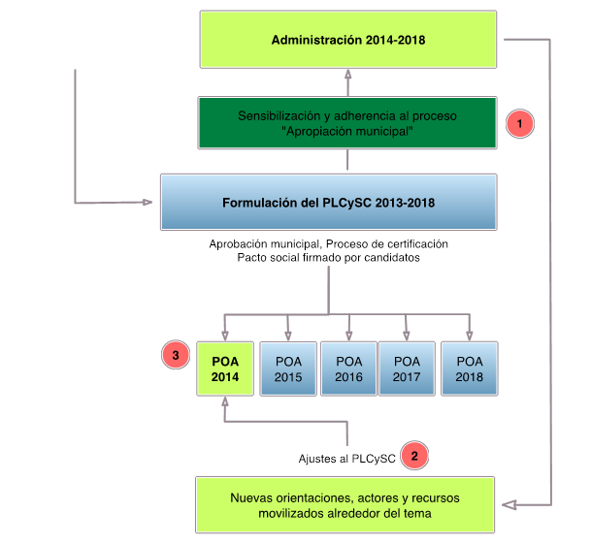
Source: “Steps for Implementing Local Plans for Coexistence and Citizen Security. The Experience of Five Municipalities in Honduras,” 2014.

2.3 IMPLEMENTATION CHALLENGES AND OPPORTUNITIES

Challenges:
- One of the main challenges has been the funding of the actions and activities included in the PLCySCs and AOPs.

- There is not a municipal-level entity that integrates of all the actions and information being produced regarding citizen security, which does not allow for the institutionalization of the process. In terms of sustainability, the municipal government needs an agency or entity to undertake the process.

- Consolidating a methodological process that facilitates the investment in preventing insecurity because the various actors involved do not provide information to the municipal experts. Even the municipal administration has had difficulties establishing the budget that it is implementing.

- The demonstration of early results of the Project’s interventions to prevent insecurity at the municipal level would help adjust technical assistance towards a process of evaluation.

- Encourage the formulation of comprehensive interventions at the municipal level with the participation of various actors, facilitating the optimization of resources and effort. Likewise, that operators at the municipal level are involved in the various implementation processes.

- Raise awareness among justice and security sector administrators to ensure their buy-in to the process, from the formulating the AOP to measuring interventions in crime control and deterrence.

Opportunities:
- The possibility of linking actions included in the 2014 AOP and therefore the Local Plan for Coexistence and Citizen Security in the municipal planning processes for 2015. Some municipalities are allocating resources for activities that will not be possible to implement in 2015.

- The inclusion of mayors and vice-mayors in the process has helped raise the profile of the municipal administration and the technical cooperation of UNDP.

- Through training and inclusion of the municipal liaisons, UNDP has held working seminars with mayor’s offices and other municipal staff, prepared and conducted accountability activities, drafted reports about activities, and organized municipal work teams to manage various resources (map of stakeholders and formulation of indicators).

- The inclusion of technical assistance in all components at the municipal level has become a reference point to internally facilitate the articulation and integration of actions.

3. COLLABORATION AND/OR KNOWLEDGE SHARING WITH OTHER USAID ACTIVITIES

3.1 RELATIONSHIP WITH OTHER USAID ACTIVITIES
UNDP was in contact with various CARSI implementers in the process of creating the local plans for coexistence and citizen security in the five target municipalities. Additionally, other CARSI implementers were included in the process of creating and implementing the informal training. Among others, UNDP has also worked with NDI (National Democratic Institute), the Impactos Program, and AJH (Alianza Joven Honduras or Youth Alliance of Honduras).

3.2 KEY HIGHLIGHTS OF THE COLLABORATION
One of the most important efforts of the project has been the formulation and implementation of a Local Municipal Plan for each of the target municipalities. This has allowed a series of outreach activities with various actors, such as:
- Come to agreement with the municipal team on the dates to conduct workshops focused on prioritization of citizen insecurity problems, formulation of activities and validation of the Plan at the institutional and community levels.
- Make institutional visits to learn about the actions proposed in the new management plans as well as the estimated budgets.
- Develop workshops focused on prioritizing problems of citizen insecurity.
- Develop workshops to formulate actions.
- Conduct workshops to validate the Plan.
- Raise awareness about the Local Plan with municipal staff for their respective adjustments.

These activities of working in a team have facilitated the consolidation of the achievements and commitments at the local level in each of the five target municipalities.

3.3 CHALLENGES OF THE COLLABORATION
The regular meetings convened by USAID for CARSI implementers have been extremely useful and have represented a support for better cooperation and coordination at the local level.

4. COLLABORATION AND/OR KNOWLEDGE SHARING WITH GOVERNMENT PARTNERS OR OTHER DONORS

4.1 LIST AND DISCUSS LINKS WITH RELEVANT MINISTRIES AND DONOR AGENCIES
During this period, UNDP participated in the G-16’s Roundtable on Justice, Security, and Human Rights, which now has a strategic planning tool and has served as a space to coordinate efforts regarding justice, security, and human rights. At the same time, UNDP has participated in the Group for Violence Prevention where the Project has been able to share experiences, lessons learned, and best practices with other donors and implementers.

Also during this period, UNDP conducted an internal evaluation of this Project and the Human Rights Project (which are both supported by USAID) as part of the 2012-2016 United Nations Development Assistance Framework (UNDAF or Marco de Asistencia de las Naciones Unidas para el Desarrollo, MANUD in Spanish): “In the context of international and national human rights instruments, the State and the people implement policies and practices that strengthen the Rule of Law and contribute to reducing violence, especially among the most vulnerable.” Among the main positive findings:

- Policy documents for human rights and for citizen security and coexistence, whose formulation was supported by UNDP and other agencies, are in effect and the current authorities have confirmed that they are under the framework of institutions that protect these policies.

- UNDP initiatives to strengthen capacities in the areas of human rights and citizen security and peaceful coexistence have been recognized as being of high quality and have influenced the protocols of public institutions responsible for human rights and in the municipal offices for mediation and reconciliation.

- The local initiatives supported or encouraged by UNDP, such as the Local Plans for Coexistence and Citizen Security (PLCySC) and the Mediation and Reconciliation Units (UMCs) which have developed an innovative methodology to facilitate reconciliation, have shown important results in terms of building a culture of peaceful coexistence and violence prevention. Additionally, the Municipal Offices for Women (OMMs), the networks of community mediators, and the COMVIDAs have been institutionalized and are being funded by the respective municipalities.

- The international community and government officials have recognized the quality of UNDP’s technical assistance and advice regarding citizen security and human rights provided over the past two years, which is also demonstrated in the quality of the documents produced.

5. SPECIAL REPORTING REQUIREMENTS (USAID FORWARD, PRESIDENTIAL INITIATIVE)
Not applicable

6. INTEGRATION OF CROSS-CUTTING VARIABLES

6.1 GENDER
In developing the Local Plans for Coexistence and Citizen Security (PLCySCs) and strengthening the Municipal Offices for Women (OMMs), UNDP has worked to incorporate a gender focus in the formulation of the annual operating plans (AOPs) in Choloma, La Ceiba, San Pedro Sula, and Tela and in the PLCySC of the Central District, which now includes an objective addressing violence against women. This gender focus includes actions regarding domestic violence, femicides, and sexual violence, among others. Significantly, this experience represents the first time that gender issues have been specifically included in the municipal operating plans.

Together with the OMMs and the National Institute for Women (INAM), UNDP drafted an operating manual. Additionally, UNDP is supporting the installation of a computer system that will link the OMM and INAM and facilitate the sharing of information.

Also regarding citizen security, UNDP has conducted an assessment of violence against women in the five target municipalities. In addition, UNDP has drafted a guide to formulate citizen security plans with a gender focus and has begun to train networks of women in the four northern target municipalities on the topic of citizen security. Finally, UNDP has begun the course for a Certificate in Gender, Coexistence, and Citizen Security.

Ethnic Groups
As part of the Units for Mediation and Reconciliation (UMCs), UNDP worked with leaders from the Garífuna villages of Corozal in La Ceiba and Tornabé in Tela. Corozal now has two community mediators, while Tornabé has four coexistence promoters and four mediators. Currently, UNDP is training more leaders in Corozal so that during 2015 the network will be widened among the Garífuna communities.

6.2 ENVIRONMENTAL COMPLIANCE
Based on guidance from USAID, the Project developed an environmental mitigation plan for the Community Coexistence Places that were renovated, namely in La Ceiba and Tela. Because these sites were provided by the communities and were places such as schools or community centers, the environmental impact and level of pollution was minimal. Workers were experts who used appropriate safety equipment.

6.3 GLOBAL CLIMATE CHANGE
Not applicable

7. ADMINISTRATIVE AND MANAGEMENT ISSUES

7.1 CONSTRAINTS AND CRITICAL ISSUES
UNDP has experienced a series of difficulties with regards to the financing from the central and local governments to implement the AOPs, specifically San Pedro Sula, which cannot obtain loans, and Tela, which has its accounts held in a trust until 2025. Nevertheless, in Tela, the municipal government has been able to raise funds through the private sector to recover public spaces, as part of the businesses’ corporate social responsibility. Of the five target municipalities, only La Ceiba and San Pedro Sula have received funds from the Security Tax to implement projects in their municipalities.

7.2 PERSONNEL
With the hiring of a technical expert in Tela and a technical liaison in Tegucigalpa, UNDP’s technical assistance team is complete. UNDP has also strengthened the team with the recruitment of a monitoring and evaluation expert, which will facilitate better monitoring of the Project’s activities.
To implement the University Certificate in CPTED, UNDP has hired Macarena Rau. Additionally, the contract of the CPTED specialist has been extended from June to December 2014 to continue providing support to IDECOAS-FHIS. UNDP also hired a consultant to design the communications strategies for the Youth and Culture component, the component to strengthen the Municipal Offices for Women (OMMs), and the UMC component. UNDP hired consultants in civic culture to conduct artistic workshops on living statues, mime, and mural-painting. Finally, UNDP financially supported the hiring of technical staff of IUDPAS to process information from the local violence observatories, as well as experts at DIM-FHIS.

7.3 CHANGES TO ACTIVITIES
UNDP has begun a grants program together with the municipalities of San Pedro Sula, Tela, Choloma, La Ceiba and the Central District to provide micro-capital funds to support youth entrepreneurial projects. Additionally, UNDP and UNAH have an agreement to teach certificates on Gender, Mediation and Reconciliation, and Situational Prevention (CPTED). There is also a grant between UNDP and the non-profit organization Hermanas de la Misericordia. UNDP has begun a fund to generate opportunities with the groups Buyara and Ayacaste. The micro-capital agreement with IDECOAS aims to build the capacity of FHIS to design, manage, and implement social infrastructure projects using CPTED methodology and facilitate knowledge transfer among municipal officials. This agreement between IDECOAS and UNDP will be implemented in the municipalities of the Central District, San Pedro Sula, Choloma, Tela, and La Ceiba. All these activities were discussed with and approved by USAID.

7.4 MODIFICATIONS AND AMENDMENTS
Not applicable

8. EVALUATIONS AND LESSONS LEARNED

8.1 LESSONS LEARNED AND BEST PRACTICES
Please see the section on Challenges and Opportunities.

An internal review is scheduled for the following period (October 2014 – March 2015).

8.2 ACTIONS AND NEXT STEPS
Many of the activities planned for the next period aim to assess and review the Project’s interventions and review the semi-annual plan, the improvement plan, and the monitoring and evaluation plan. The systemization of the mediation and reconciliation process is already underway, and next period UNDP will also systematize the experience of the Local Plans for Coexistence and Citizen Security. UNDP is currently drafting a sustainability plan and a year-end review. Monthly meetings will be held with the entire team to coordinate and make adjustments as necessary.

In terms of activities, UNDP will:
- support the final accountability review of the municipalities’ Annual Operating Plans (AOPs);
- conduct the informal training in the Central District;
- finish the certificate trainings;
- continue to work with justice administrators on the issue of conflict mediation and reconciliation;
- finish the certificate in mediation and reconciliation for community and citizen coexistence; and
- develop an action plan for 2015 in which alumni of the certificate can work with the UMCs in their municipalities and UNDP strengthens the network of community coexistence volunteers (AVCCs) and raises the profile of the UMCs with the municipal government;
UNDP will provide technical assistance to the UMCs to work with the national network of alternative conflict resolution methods that coordinates with the Judiciary with the support of the Organization of American States (OAS) and advocate for the implementation of public policies that favor mediation and reconciliation. As such, UNDP will begin a series of dialogues with the Special Programs Unit of the Judicial Facilitators, the Judiciary, and other institutions to raise certain strategies and create roundtables to formulate a legislative proposal to strengthen mediation and reconciliation in the country.

9. ACTIVITIES PLANNED FOR THE NEXT SEMESTER

Planned Activities from previous semester  (April – Sept 2014) | Current Status (September 2014) | Explanation for Changes | Proposed Activities for the next semester  (Oct 2014 – March 2015)
1. Strengthen the local violence observatories in Choloma, La Ceiba, San Pedro Sula, and Tela, with citizen participation modules | - Creation of a local violence observatory in Tela  - Training of coordinators and the technical staff of the local violence observatories  - Technical assistance to the local violence observatories  - Building the capacity of and coordination of actions with the municipal mayor’s office and its committees  - Technical cooperation agreements with UNAH regional directors in SPS and Tela  - Presentation of the 2013 bulletins and information for the first 6 months of 2014  - Working meeting with regional officials of the National Police |  | - Validating, updating, and diagramming the results of the local violence observatories at the national, departmental, and municipal levels  - Analysis of the results and presentation of the 2014 annual bulletins  - Assist technical teams of the violence observatories to analyze and present the scientific evidence of the bulletins to official sources, the security committee, the municipal government, and society in general  - Draft thematic, geo-referenced maps of deaths by external causes and crime in Tela and La Ceiba  - Geo-reference the tourist sites in Tela
2. Create a Violence Observatory in the Central District | Presentation to the Security and Coexistence Council in the 1st meeting of the Central District to improve levels of information and encourage discussion, reflection, and design of violence prevention and coexistence strategies. | Pending, given that UNDP has not been able to access information of the National Police, but is in talks with the Ministry of Security | Create a Violence Observatory for the Central District in IUDPAS.
3. Train mayors, municipal officials, and civil society on citizen security and promotion of coexistence, including the participation of women. | Process of “informal” training begun in Choloma, La Ceiba, and Tela. Pending in San Pedro Sula and the Central District  San Pedro Sula: In the process of training municipal officials. Developing a workshop on the national and municipal guidelines that support the development of citizen security actions. Also raised awareness about the activities conducted to formulate the PLCySC and 2014 AOP. | Central District: Because PLCySC has not yet been approved, UNDP cannot begin training municipal officials. Nevertheless, at the recommendation of the municipal expert, UNDP conducted a workshop for staff in the mayor’s office about the differences in the concepts of human security and citizen security, linking the latter to local development. | 1. Finalize content for Choloma, La Ceiba, and Tela  2. Continue developing the content for San Pedro Sula and the Central District after selecting participants
4. Develop a Local Plan for Coexistence and Citizen Security (PLCySC) in the Central District, with specific actions to improve the security of women and girls. | Plan created | Awaiting approval of the PLCySC in town hall meeting | UNDP hopes the Local Plan will be approved in October 2014
5. Strengthen the capacity of FHIS to design, manage, and implement social infrastructure projects using CPTED methodology and facilitate knowledge transfer to municipal officials and other stakeholders. | Signed agreement with IDECOAS  Trained municipal officials and staff of IDECOAS FHIS |  | 2nd part of the certificate training will be developed in November 2014
6. Train mayors, public officials, and community leaders in CPTED and PEC methodologies, in collaboration with FHIS. | Mayors and public officials trained in CPTED methodology. |  | - Develop 2nd module in November 2014  - Study tour to Chile in November 2014
7. Strengthen the management of citizen security and coexistence in the Central District, San Pedro Sula, Choloma, Tela, and La Ceiba. | Activity conducted | In the process of defining how the planning process will be integrated into the mayors’ offices to ensure the sustainability of the process. | - The final accountability exercise will be held in January 2015  - Consolidation of the 2015 planning process
8. Develop citizen conflict mediation and reconciliation units with a network of community mediators. | Activity in progress |  | - Reopening of the UMC in Central District  - Develop 5th and 6th modules in the Certificate in Community Conflict Mediation and Reconciliation  - Workshop on Code of Ethics for trainers such as AVCCs
9. Strengthen the citizen conflict mediation and reconciliation units and network of community mediators in the Central District | Activity in progress | Complications in coordination at the municipal level for actions to reopen the UMC in the Central District | Seminar with justice administrators in the Central District to: (1) promote alternative methods of conflict resolution, (2) refer of cases to the UMC, (3) reopen the UMC, (4) create a municipal network of AVCCs, and (5) open a Community Coexistence Place.
10. Strengthen the capacity of Municipal Offices for Women to develop strategies to prevent gender violence in the target municipalities. | Assessment drafted and being reviewed | Delays in review of assessment.  In the process of defining how the planning process will be integrated into the mayors’ offices to ensure the sustainability of the process. | - Revise, update, and finalize the assessment  - Final accountability exercise scheduled for January 2015.  - Consolidation of the 2015 planning process.
11. Develop a plan for sub-grants to support women’s organizations promoting work with the Offices for Women in target municipalities. | Grant signed with the non-profit organization, Hermanas de la Misericordia |  | In progress, expected to finish during the first quarter of 2015
12. Strengthen strategies to promote art and a culture of peace in the target municipalities. | Work in development under the methodology of youth-to-youth training, in cooperation with COMVIDAs in the 5 target municipalities |  | Conduct workshops on artistic skills including mural-painting, stilt-walking, drumming, hip-hop dancing, living statues, and miming.  Training in civic culture.

13. Promote strategies encouraging art and citizenship in the Central District. | Workshops in drumming, mural-painting, zamba, break dancing, and stilt-walking |  | Continue facilitating workshops for youth
14. Develop a violence prevention campaign in the media directed at youth in the target municipalities. | Together with the youth who received artistic training, developed a communications campaign to prevent violence and crime, with the goal of dignifying and valuing youth based on the premise that that “Being young is not a crime: Because youth also contribute to building citizenship” |  | Campaign will begin in January 2015.  During the production phase, it will be validated with the participating youth and a draft will be presented to the mayor’s office in each municipality with the hope that they will become co-sponsors
15. Develop a program to train youth facilitators in art and citizenship. | In process. To date, 18 facilitators have been trained in conducting artistic workshops, training a total of 277 youth in 5 municipalities. |  | Selection of a group of young artists in each municipality who will be trained in pedagogical material so they can replicated the experience in other neighborhoods of their municipality
16. Develop a program to promote entrepreneurship for youth organizations connected with initiatives to promote a culture of peace through art. | In process. Encouraging entrepreneurship among individuals or groups of at-risk youth, who present businesses related to the promotion of culture, tourism, gastronomy, a culture of peace, and other innovative products. |  | Provide for the creation of a Fund to Generate Entrepreneur Opportunities for Youth in La Ceiba, Tela, Choloma, and San Pedro Sula.
17. Design a System of Indicators and other tools for monitoring and evaluation | - Monitoring of activities  - Drafting of regular reports  - Monitoring of indicators |  | System of indicators and monitoring and evaluation tools

10. FINANCIAL INFORMATION

Budget:
 | Original grant  (September 30, 2011) | Modification 3 (September 26, 2013) | Total
Federal | $773,610.00 | $2,293,755.79 | $3,067,365.79
Non-Federal | $211,855.61 | $294,000.39 | $505,856.00
Total | $985,465.61 | $2,587,756.18 | $3,573,221.79

  - Financial Status as of September 30, 2014

Award | 00051471 | 00069551
Output | 00069443 | 00084068
Component | 3 | 3
Name: | Citizen Security and Coexistence (Initial) | Citizen Security and Coexistence (Modification 4) | Total Component 3
Federal Cash
a. Cash Receipts | $773,610.00 | $2293,755.79 | $3067,365.79
b. Cash Disbursements | $772,828.85 | $1024,325.73 | $1797,154.58
c. Cash on Hand (line a minus b) | $781.15 | $1269,430.06 | $1270,211.21
Federal Expenditures and Unobligated Balance:
d. Total Federal funds authorized | $773,610.00 | $2293,755.79 | $3067,365.79
e. Federal share of expenditures | $772,828.85 | $1024,325.73 | $1797,154.58
f. Federal share of unliquidated obligations | $641.29 | $644,883.76 | $645,525.05
g. Total Federal share (sum of lines e and f) | $773,470.14 | $1669,209.49 | $2442,679.63
h. Unobligated balance of Federal funds (line d minus g) | $139.86 | $624,546.30 | $624,686.16
Recipient Share:
i. Total recipient share required | $211,855.61 | $294,000.39 | $505,856.00
j. Recipient share of expenditures | $733,026.78 | $161,644.05 | $894,670.83
k. Remaining recipient share to be provided (line i minus j) | -$521,171.17 | $132,356.34 | -$388,814.83

11. BRANDING, COMMUNICATIONS & DISSEMINATION

11.1 KEY COMMUNICATIONS ACTIVITIES – specific activities that reflect branding awareness for USAID

The communications activities that occurred during April to September 2014, raised awareness of the Project’s activities through:
- Monthly bulletins
- Life stories
- Thematic bulletins
- Management of social networks
- Communications products

11.2 BRANDING

Communications Strategy
Communication in development work is more than simply using the media, it’s the way in which a project relates to the citizenry. In order to raise visibility of the Project’s activities in a comprehensive way and incorporate the experience in the local public agenda, the Project must:
- Generate communications mechanisms to legitimize the Project’s issues;
- Channel and demonstrate the priority issues for the citizenry; and
- Implement actions to raise awareness and visibility, such as campaigns, celebrations, and performances.

Communications Products:

Monthly Bulletins
April: http://issuu.com/promoviendoconvivencia/docs/boletin_mensual_-_abril_2014
May: http://issuu.com/promociondeconvivencia/docs/boletin_mensual_-_mayo__2014
June-August: http://issuu.com/promociondeconvivencia/docs/boletin_trimestral_-_seguridad_ciud
September: http://issuu.com/promociondeconvivencia/docs/v2-boletin_mensual_-_septiembre_201

Folders

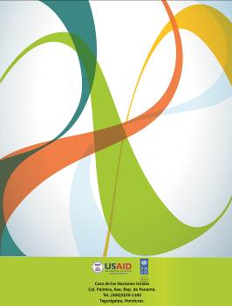
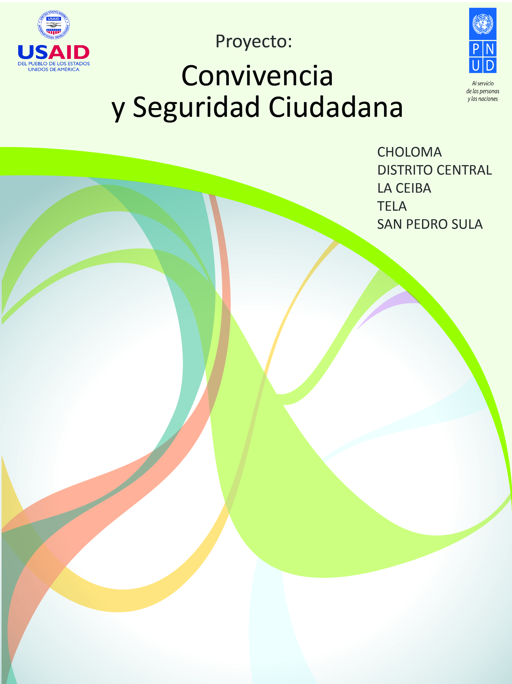

Social Networks
As part of the Project’s communications strategy, UNDP is using Facebook, Blogspot, YouTube, Twitter, and a webpage. To use these tools, UNDP must generate content, continually update them, and broaden its contacts. Network communication is horizontal, interactive, and personalized. It is most effective when it is considered a priority among the Project’s communications activities. The Coexistence and Citizen Security Project uses these tools in the following ways:
- Blogspot: Journalist/literary writing published to share experiences, methodologies, themes of interest, and to interact with users. http://promoviendoconvivencia.blogspot.com/
- YouTube: Stories, capsules, and videos about themes or activities. It is useful to raise awareness and disseminate messges in a short time with illustrative videos.
- Twitter: Short, clear texts, supplemented with a photograph, allow the messages to be retweeted by other users. https://twitter.com/PNUD_seguridadc
- Facebook: Photo album with detailed text. Its publication is shared with the online community. Broad scope. https://www.facebook.com/convivenciayculturaciudadana
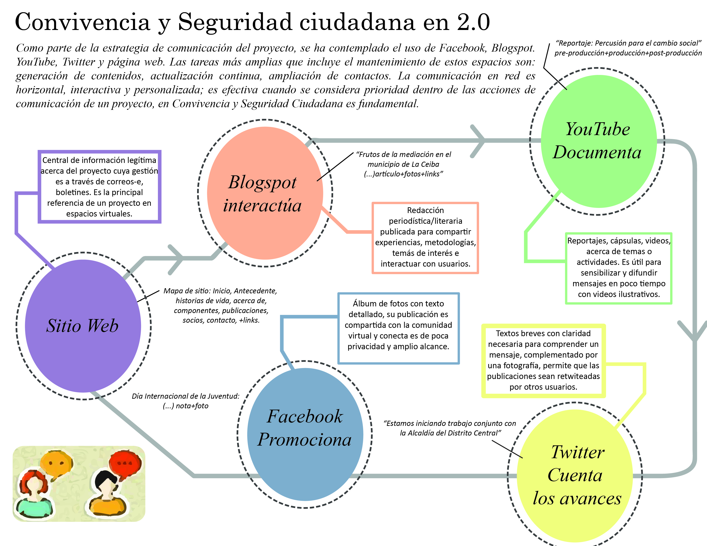

12. SUSTAINABILITY AND EXIT STRATEGY

UNDP has proposed the creation of a sustainability plan, looking to coordinate with local stakeholders on the formulation, implementation, and evaluation of the local plans for coexistence and citizen security which have been drafted in the five target municipalities. It is vital to define the actions necessary to transfer processes, knowledge, and equipment to ensure the capacity of the municipalities to prevent violence and improve citizen security.

The development of a sustainability plan with input from various stakeholders is essential to ensure the continuity of the products and services initiated by the Project and offered in the target municipalities. It is critical that local institutions ensure the continuation and follow-up of the coexistence and citizen security processes implemented at the municipal level, especially those established in the PLCySCs.

13. ANNEXES

13.1 SUCCESS STORIES

Youth Building Citizenship Promote Peaceful Coexistence through Urban Dance

Youth in Honduras have enormous potential, but their reality is marked by instability and exclusion. Among the various forms of social exclusion facing Honduran youth are insecurity and discrimination, both of which limit the fulfillment of their potential, especial for young women. 26.7% of the Honduran population finds its recreation activities limited by the country’s insecurity. LAPOP, UNDP, 2012

Faced with this difficulty, hundreds of youth in Honduras are seeking alternatives that allow them to access learning and development opportunities, where they can use their skills and abilities to improve their living conditions. Urban dance, better known as break dancing, is an artistic expression that talented youth want to challenge themselves with.

Breakdancing is a series of body movements set to the beat of hip-hop music. This type of dance is recognized around the world. Its elements include toprock (dancing standing up), footwork (moves on the floor), and the freeze (freezing one’s body in a posture).

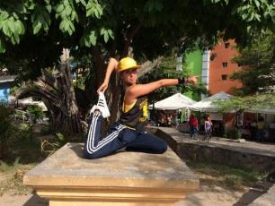
“For me, breakdancing isn’t just a part of my life, it is my life. Dancing for me is more than a hobby and in the years of life that I have, it’s what I will do. My body feels free. It’s a form of releasing energy, instead of fighting or criticizing why someone doesn’t dance,” explains Yoselin Alexandra Varela, a breakdancer (b-girl) known as “BigAJess”

“I’m a breaker-boy or b-boy and for me it’s a lifestyle of love and peace, that includes everything related to the social development of a person. Every time we have a show, we have a session where we try to plan a little, but when we hear the music, that’s what moves us, and the energy makes us do a trick or freeze.”

Since 2009, UNDP, through its “Coexistence and Citizen Security” project has sought to improve civic culture among more than 200 youth by providing artistic training in mural-painting, drumming (batucada), stilt-walking, miming, and breakdancing. This alternative form of social expression has given youth an opportunity to channel their energies and emotions in a collective way to perform in front of more than 200 people and the media in some of the most violent municipalities in the country, enhancing their participation with messages that promote values and social integration.

UNDP’s “Coexistence and Citizen Security” project, supported by USAID, provides technical cooperation to the municipalities of Choloma, La Ceiba, San Pedro Sula, Tela, and most recently the Capital District. UNDP implements community strategies to promote peaceful coexistence and citizen security aimed at youth, women, and other citizens in the target municipalities. The Project’s municipal partners working to prevent violence include the Municipal Offices for Women, Units for Mediation and Reconciliation, and the Municipal Office for Youth, COMVIDA.

This year the Project has organized workshops on youth-to-youth training methodology – workshops for facilitators of art and drumming, and soon miming and entrepreneurship. There have also been a series of public presentations centered around key celebrations such as the International Day of Theater, the Carnaval of La Ceiba, International Population Day: Investing in Youth, and the Day for Youth. This public presentations consist of artistic troupes and are generally accompanied by a walk in the municipality with posters raising awareness about the key themes and information booths about civic culture and peaceful coexistence.

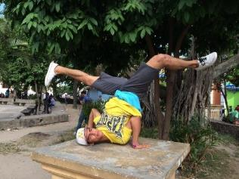
“Being a b-girl or b-boy, you don’t think about drinking alcohol or smoking because you need to be healthy. Instead of thinking about all that, you think about your next trick or freeze, how you can do it better and improve yourself, all to feel good about yourself.”

“I know that I’m different than the other girls because breakdancing is my passion. Obviously I can’t practice in a mini-skirt; I need my track suit, my sneakers, my hat. People need to understand that the world is changing. Guys have muscles, but we girls have strength in our souls and our hearts.”
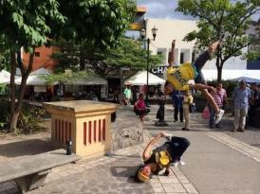
“The United Nations has decided to support us because they know what is good. They have supported us for a while and here we are making people see beyond a crooked hat. The people need to appreciate that we are expressing ourselves. I have had the opportunity to participate in town hall meetings so that everyone in my town sees that behind my hat there is a person with skills, knowledge, and they don’t point at us in the street. Discrimination is already history.”

At the end of 2014, the Project will organize an event so that the target municipalities can describe their experiences in formulating and implementing a Local Plan for Coexistence and Citizen Security. UNDP also expects to launch a communications campaign on gender, mediation, and youth before the end of the year.

The participation of youth in the construction of a more inclusive, fair, and united Honduras is fundamental for the social development of communities and the country as a whole. In this way, the Coexistence and Citizen Security Project focuses on encouraging committed and active participation that empowers youth in their rights and strengthens civic culture.

http://www.hn.undp.org/content/honduras/es/home.html

Community Leader Trained as Coexistence Promoter

Certain sectors of the population, such as women and girls that live in poverty, confront various forms of discrimination and, as a result, also suffer a higher risk of being a victim of violence. In order to effectively address violence against women, it is necessary to have a comprehensive strategy that includes a wide range of actors. This approach should include the formulation of laws and policies, prevention and support services, and a change of norms and behaviors among men and boys, in addition to incorporating data collection and research. An important component of prevention efforts is to generate awareness and organize campaigns about the scope and impact of the violence. These actions should be supplemented with educational programs and community mobilization in order to obtain continuous results.

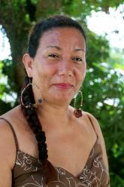
The municipality of Tela is composed of 96 neighborhoods, 74 villages, and 231 rural hamlets. It is a municipality with a wide range of tourist attractions and is a commercial center for various trade and fishing businesses. Although it is an important source of resources for the country, Tela faces a number of social problems that require the implementation of community conflict resolution strategies to prevent violence. Therefore, UNDP is conducting a series of actions to strengthen the network of community coexistence volunteers, formed by more than 20 leaders from three communities in the municipality.

Among these community leaders is Mrs. Silvia Lara, a 45-year-old woman who lives in the Buenos Aires neighborhood of Tela and sells clothing. Mrs. Lara, a promoter for the Unit for Mediation and Reconciliation, leads community talks about peaceful coexistence for youth, adults, and children. She briefly explained the social difficulties in her municipality and how the actions of coexistence help the people, “Before I was part of the network of promotors, I led groups of leaders and taught the themes by instinct. Now I base my learning seminars on the coexistence manual, which explains each topic in an organized and practical way.”

This year, UNDP’s Coexistence and Citizen Security Project, supported by USAID, has opened eight (8) Community Coexistence Places (Puntos de Convivencia Communitaria or PCC) in the municipalities of Choloma, La Ceiba, San Pedro Sula, and Tela. The main quality of every community leader is to have the desire to be part of a social change in his or her municipality. “I feel good when I see people smile, we started with 3 hours and ended with 5. I enjoy the experience of being a promoter because no matter where you are doing it, you always gain knowledge,” explains Silvia.

The promotion of peaceful coexistence consists of disseminating information through awareness raising campaigns, meetings, and talks which encourage citizens to practice the 7 pillars of coexistence that contribute to the common welfare of the municipality. Coexistence promotors have a distinct role from the volunteer mediators who invite two parties to resolve their conflict with through a process of mediation facilitated by a third neutral party to come to a resolution which both agree to. “The workshops that I facilitate I call Conversations, because it is dialogue which avoids problems. In my neighborhood, people frequently say, ‘he told me, and I told him.’ These people discover that dialogue erases lies, gossip, and misunderstanding.”

“The network of community volunteers is growing because whenever we have talks, people ask us ‘how do you know this?’ and other people ask how they can get involved and if they can do it on the weekends. Just this week, two neighbors joined.” For the network to expand, more Places of Coexistence need to be opened, the work that the UMCs does needs to be strengthened, and more and more volunteers need to be interested in disseminating the idea that coexistence leads to community development and an improved quality of life.

Mrs. Silvia Lara is a clear example of the effectiveness with which women participate in community spaces to learn about their rights and use their skills to promulgate the values of coexistence. She is an example for the community because her actions go beyond exercising her rights, they developed broad levels of awareness about coexistence.

13.2 TRAINING REPORT

Name of the training programme | Field of study | Relationship to the objectives | Start date | End date | Estimated cost (US$) | Number of males | Number of females
Workshop on the Use and Analysis of Information and Presentation of Bulletins | Local Violence Observatories | Publication of informative bulletins | July 15 | July 19 | 2,195.10
Workshop on profiling projects and identifying funding sources for the municipalities of Choloma, La Ceiba, San Pedro Sula and Tela | Local Plans for Coexistence and Citizen Security | Training of mayors, municipal officials, and civil society in citizen security and the promotion of coexistence, including the participation of women | May 22 | May 22 | 2,286.18 | 12 | 6
Workshop with leaders to prioritize the problems of citizen insecurity | Local Plans for Coexistence and Citizen Security | Training of mayors, municipal officials, and civil society in citizen security and the promotion of coexistence, including the participation of women | April 25 | May 2 |  | 25 | 36
Workshop to review the actions of the Local Plans and identify new lines of action in La Ceiba, San Pedro Sula, Choloma and Tela | Local Plans for Coexistence and Citizen Security | Training of mayors, municipal officials, and civil society in citizen security and the promotion of coexistence, including the participation of women | March 19  March 25  March 27  April 2 | March 19  March 25  March 27  April 2 | 1,517.34  1,700  1,750  1,900 | 32  36  44  34 | 33  40  36  55
First training workshop (informal education) for municipal officials from Choloma & La Ceiba | Local Plans for Coexistence and Citizen Security | Training of mayors, municipal officials, and civil society in citizen security and the promotion of coexistence, including the participation of women | June 18  June 20 | June 18  June 20 | 1,023.66  1,100 | 7  7 | 13  18
Second training workshop (informal education) for municipal officials from Choloma & La Ceiba | Local Plans for Coexistence and Citizen Security | Training of mayors, municipal officials, and civil society in citizen security and the promotion of coexistence, including the participation of women | July 17  July 24 | July 17  July 24 | 1,288.34  1,250 | 25  8 | 15  23
First verification of the implementation of actions from the 2014 AOPs in Choloma, La Ceiba, San Pedro Sula and Tela | Local Plans for Coexistence and Citizen Security | Training of mayors, municipal officials, and civil society in citizen security and the promotion of coexistence, including the participation of women | June 25  June 26  July 31  August 28 | June 25  June 26  July 31  August 28 | 1,852.62  1,900  1,800  1,800 | 35  24  29  22 | 20  38  19  12
First and second training workshops (informal education) for municipal officials from Tela | Local Plans for Coexistence and Citizen Security | Training of mayors, municipal officials, and civil society in citizen security and the promotion of coexistence, including the participation of women | August 29 | August 29 | 1,800 | 19 | 9
Third training workshop (informal education) for municipal officials from Choloma, La Ceiba & Tela | Local Plans for Coexistence and Citizen Security | Training of mayors, municipal officials, and civil society in citizen security and the promotion of coexistence, including the participation of women | Sept 17  Sept 18  Sept 19 | Sept 17  Sept 18  Sept 19 | 1,500  1,500  1,500 | 8  14  8 | 19  7  12
First training workshop with members of the Prevention Committee and the Security Committee | Local Plans for Coexistence and Citizen Security | Training of mayors, municipal officials, and civil society in citizen security and the promotion of coexistence, including the participation of women | Sept 24 | Sept 24 | 1,500 | 15 | 8
Consolidation of the Security Committee under the jurisdiction of the mayor’s office in San Pedro Sula | Local Plans for Coexistence and Citizen Security | Training of mayors, municipal officials, and civil society in citizen security and the promotion of coexistence, including the participation of women | Sept 17 | Sept 17 | 1,500 | 11 | 4
Units for Mediation and Reconciliation (UMCs)
Meeting of UMC coordinators (SPS, Choloma, La Ceiba & Tela) | Strengthening the Units for Mediation and Reconciliation | Strengthening the Units for Mediation and Reconciliation of Citizen Conflicts with a Network of Community Mediators in the Central District | July 3 | July 5 | 2,772.02 | 2 | 9
Workshop with Justice Operators | Strengthening the Units for Mediation and Reconciliation | Strengthening the Units for Mediation and Reconciliation of Citizen Conflicts with a Network of Community Mediators in the Central District | Sept 30 | Sept 30 | 200 | 3 | 12
Ethics Protocol | Strengthening the Units for Mediation and Reconciliation | Development of Units for Mediation and Reconciliation of Citizen Conflicts with a Network of Community Mediators in Choloma, Tela, San Pedro Sula and La Ceiba | April 7 | April 8 | 1,221.18 | 20 | 52
Promotion of the 15th of September PCC | Strengthening the Units for Mediation and Reconciliation | Development of Units for Mediation and Reconciliation of Citizen Conflicts with a Network of Community Mediators in Choloma, Tela, San Pedro Sula and La Ceiba | July 25 | July 26 | 2,000 | 5 | 11
Motivation and Awareness Raising Module in Choloma, La Ceiba & Tela | Strengthening the Units for Mediation and Reconciliation | Development of Units for Mediation and Reconciliation of Citizen Conflicts with a Network of Community Mediators in Choloma, Tela, San Pedro Sula and La Ceiba | May 5  July 8  August 21 | May 8  July 11  August 23 | 4,728.42  2,000  2,500 | 12  14  7 | 28  19  26
Opening of PCCs in Choloma, La Ceiba, San Pedro Sula & Tela | Strengthening the Units for Mediation and Reconciliation | Development of Units for Mediation and Reconciliation of Citizen Conflicts with a Network of Community Mediators in Choloma, Tela, San Pedro Sula and La Ceiba | May 27 | May 29 | 5,000 | 164 | 455
Training Workshop for Mediators in La Ceiba & San Pedro Sula | Strengthening the Units for Mediation and Reconciliation | Development of Units for Mediation and Reconciliation of Citizen Conflicts with a Network of Community Mediators in Choloma, Tela, San Pedro Sula and La Ceiba | August 13 | August 16 | 2,500 | 12 | 39
Focus Groups and Interviews in Choloma, La Ceiba, San Pedro Sula & Tela | Strengthening the Units for Mediation and Reconciliation | Development of Units for Mediation and Reconciliation of Citizen Conflicts with a Network of Community Mediators in Choloma, Tela, San Pedro Sula and La Ceiba | August 11 | August 12 | 3,000 | 25 | 49
First Workshop with Justice Operators in San Pedro Sula, Tela & La Ceiba | Strengthening the Units for Mediation and Reconciliation | Development of Units for Mediation and Reconciliation of Citizen Conflicts with a Network of Community Mediators in Choloma, Tela, San Pedro Sula and La Ceiba | June 10 | June 12 | 1,806.27 | 25 | 31
Second Workshop with Justice Operators in San Pedro Sula, Tela & La Ceiba | Strengthening the Units for Mediation and Reconciliation | Development of Units for Mediation and Reconciliation of Citizen Conflicts with a Network of Community Mediators in Choloma, Tela, San Pedro Sula and La Ceiba | August 5 | August 7 | 2,000 | 20 | 27
Visit of the United Nations Representative in Honduras to the UMCs in La Ceiba & Tela | Strengthening the Units for Mediation and Reconciliation | Development of Units for Mediation and Reconciliation of Citizen Conflicts with a Network of Community Mediators in Choloma, Tela, San Pedro Sula and La Ceiba | September 12 | September 12 | 2,800 | 10 | 18
First Module for Certificate in Mediation and Reconciliation in Tela | Strengthening the Units for Mediation and Reconciliation | Development of Units for Mediation and Reconciliation of Citizen Conflicts with a Network of Community Mediators in Choloma, Tela, San Pedro Sula and La Ceiba | July 9 | July 11 | 740.15 | 5 | 22
Second Module for Certificate in Mediation and Reconciliation in Tela | Strengthening the Units for Mediation and Reconciliation | Development of Units for Mediation and Reconciliation of Citizen Conflicts with a Network of Community Mediators in Choloma, Tela, San Pedro Sula and La Ceiba | July 31 | August 2 | 1,161.58 | 4 | 21
Third Module for Certificate in Mediation and Reconciliation in Tela | Strengthening the Units for Mediation and Reconciliation | Development of Units for Mediation and Reconciliation of Citizen Conflicts with a Network of Community Mediators in Choloma, Tela, San Pedro Sula and La Ceiba | August 28 | August 30 | 918.71 | 5 | 22
Fourth Module for Certificate in Mediation and Reconciliation in Tela | Strengthening the Units for Mediation and Reconciliation | Development of Units for Mediation and Reconciliation of Citizen Conflicts with a Network of Community Mediators in Choloma, Tela, San Pedro Sula and La Ceiba | September 18 | September 20 | 2,500 | 5 | 22

Municipal Offices for Women (OMM)
Working session to design and validate a communications campaign in San Pedro Sula, Choloma, La Ceiba, Tela & the Central District | Strengthening the Municipal Offices for Women (OMMs) in La Ceiba, Choloma, Tela, San Pedro Sula & the Central District | Strengthening the Municipal Offices for Women (OMMs) to develop strategies to prevent gender violence in La Ceiba, Tela, Choloma and San Pedro Sula | July 29  July 30  August 13  August 26  August 27 | July 29  July 30  August 13  August 28  August 27 | 1000  1000  1000  1000  1,111.40 | 2  0  0  0  0 | 6  8  13  5  5
First module for Certificate in Gender, Coexistence and Citizen Security in La Ceiba | Strengthening the Municipal Offices for Women (OMMs) in La Ceiba, Choloma, Tela, San Pedro Sula & the Central District | Strengthening the Municipal Offices for Women (OMMs) to develop strategies to prevent gender violence in La Ceiba, Tela, Choloma and San Pedro Sula | August 16 | August 18 | 1,398.80 | 4 | 36
Second module for Certificate in Gender, Coexistence and Citizen Security in La Ceiba | Strengthening the Municipal Offices for Women (OMMs) in La Ceiba, Choloma, Tela, San Pedro Sula & the Central District | Strengthening the Municipal Offices for Women (OMMs) to develop strategies to prevent gender violence in La Ceiba, Tela, Choloma and San Pedro Sula | August 21 | August 23 | 2,101.73 | 4 | 34
Third module for Certificate in Gender, Coexistence and Citizen Security in La Ceiba | Strengthening the Municipal Offices for Women (OMMs) in La Ceiba, Choloma, Tela, San Pedro Sula & the Central District | Strengthening the Municipal Offices for Women (OMMs) to develop strategies to prevent gender violence in La Ceiba, Tela, Choloma and San Pedro Sula | Sept 25 | Sept 27 | 2,200 | 3 | 37
Raise awareness of and choose dates for capacity strengthening for women’s organizations in La Ceiba, Tela, Choloma & San Pedro Sula | Strengthening the Municipal Offices for Women (OMMs) in La Ceiba, Choloma, Tela, San Pedro Sula & the Central District | Strengthening the Municipal Offices for Women (OMMs) to develop strategies to prevent gender violence in La Ceiba, Tela, Choloma and San Pedro Sula | Sept 15  Sept 17  Sept 18 | Sept 19  Sept 17  Sept 18 | 572.43  575  575 | 0  0  0 | 5  12  16
Workshop on Gender, violence against women and citizen security for the Prevention Committee “La Ceiba For All” | Strengthening the Municipal Offices for Women (OMMs) in La Ceiba, Choloma, Tela, San Pedro Sula & the Central District | Strengthening the Municipal Offices for Women (OMMs) to develop strategies to prevent gender violence in La Ceiba, Tela, Choloma and San Pedro | August 18 | August 18 | 304.35 | 4 | 12
First and Second Workshop for the participatory formulation of operating manuals for the OMMs of Tela, La Ceiba, Choloma, SPS & the Central District | Strengthening the Municipal Offices for Women (OMMs) in La Ceiba, Choloma, Tela, San Pedro Sula & the Central District | Strengthening the Municipal Offices for Women (OMMs) to develop strategies to prevent gender violence in La Ceiba, Tela, Choloma and San Pedro | July 2 | July 4 | 750.04 | 0 | 10
CULTURE
Workshop for building capacity of youth facilitators in art and civic culture | Strategies for civic culture in municipalities with high levels of insecurity and violence | Strengthen strategies for art and a culture of peace in San Pedro Sula, Choloma, Tela & La Ceiba | April 26 | April 27 | 282.68 | 14 | 8
First Workshop to Reinforce artistic skills in drumming, stilt-walking, mural-painting, and dance in La Ceiba, Tela, Choloma, San Pedro Sula & the Central District | Strategies for civic culture in municipalities with high levels of insecurity and violence | Strengthen strategies for art and a culture of peace in San Pedro Sula, Choloma, Tela & La Ceiba | May 3  May 3  May 3  May 16 Sept 27 | May 4  May 4  May 4  May 18  Sept 28 | 2600  2700  2700  2500  2,925.32 | 27  18  18  20  30 | 15  25  25  15  23
Second Workshop to Reinforce artistic skills in drumming, stilt-walking, mural-painting, and dance in La Ceiba, Tela, Choloma & San Pedro Sula | Strategies for civic culture in municipalities with high levels of insecurity and violence | Strengthen strategies for art and a culture of peace in San Pedro Sula, Choloma, Tela & La Ceiba | May 16  May 31  June 21  August 9 | May 17  June 1  June 22  August 9 | 25,000 | 30  37  15  14 | 18  17  30  11
Third Workshop to Reinforce artistic skills in drumming, stilt-walking, mural-painting, and dance in Tela, Choloma & San Pedro Sula | Strategies for civic culture in municipalities with high levels of insecurity and violence | Strengthen strategies for art and a culture of peace in San Pedro Sula, Choloma, Tela & La Ceiba | August 9  August 16  August 23 | August 10  August 17  August 24 | 20,000 | 30  26  13 | 29  31  17

Participation in the Carnaval of La Ceiba with youth groups from COMVIDAs in La Ceiba, Choloma & San Pedro Sula accompanied by social-artistic groups Ayacaste from Comayagua and Buyara from Tegucigalpa | Strategies for civic culture in municipalities with high levels of insecurity and violence | Strengthen strategies for art and a culture of peace in San Pedro Sula, Choloma, Tela & La Ceiba | May 24 | May 24 | 2,074.40 | 37 | 28
Meeting of the Violence Prevention Committee and the Chamber of Commerce in La Ceiba to present the fund for youth entreprenuers | Strategies for civic culture in municipalities with high levels of insecurity and violence | Strengthen strategies for art and a culture of peace in San Pedro Sula, Choloma, Tela & La Ceiba | May 30 | May 30 | 1,500 | 4 | 8
Focus groups with youth to create a communications campaign in La Ceiba, Tela, San Pedro Sula & Choloma | Strategies for civic culture in municipalities with high levels of insecurity and violence | Strengthen strategies for art and a culture of peace in San Pedro Sula, Choloma, Tela & La Ceiba | July 9  July 28 | July 10  July 29 | 2,000  2,000 | 13  16 | 11  11
Participation in the celebration of the International Day for Youth with youth from COMVIDAs in L a Ceiba, Chamelecón, Tela & Choloma - Joint work with UNFPA | Strategies for civic culture in municipalities with high levels of insecurity and violence | Strengthen strategies for art and a culture of peace in San Pedro Sula, Choloma, Tela & La Ceiba | August 22 | August 22 | 5,000 | 50 | 35
Participation in the Celebration of the Second Festival for Population and Development – Joint work with UNFPA | Strategies for civic culture in municipalities with high levels of insecurity and violence | Strengthen strategies for art and a culture of peace in San Pedro Sula, Choloma, Tela & La Ceiba | July 11 | July 11 | 5,000 | 22 | 18
Workshop to share methodological experiences with youth groups of COMVIDAs in La Ceiba, Tela, Comayagua, Tegucigalpa, Choloma & San Pedro Sula and Validation of the Communications campaign | Strategies for civic culture in municipalities with high levels of insecurity and violence | Strengthen strategies for art and a culture of peace in San Pedro Sula, Choloma, Tela & La Ceiba | Sept 11 | Sept 13 | 15,000 | 22 | 20
TOTAL US$ |  |  |  |  | 173,187.59

13.3 PICTURES (Events, Trainings, etc)

4 AOPs (events in SPS, La Ceiba, Choloma and Tela) and the beginning in the Central District

Events to Verify AOPs in:

La Ceiba

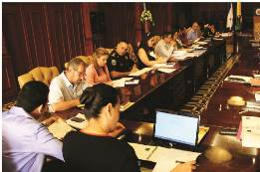 SPS

Tela

Choloma

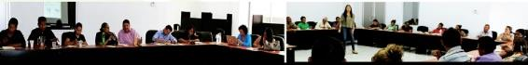
Actions to build Local Plan for Coexistence and Citizen Security through workshops to prioritize problems with social prevention, deterrence, and control.

Opening of the Places for Community Coexistence
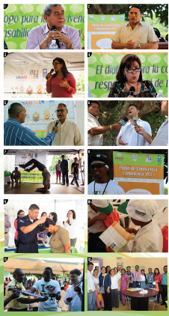

LOA – IDECOAS

Signing the agreement between UNDP & IDECOAS/FHIS

University Certificates
Gender and Citizen Coexistence

Mediation and Coexistence

Celebration of the Day of Youth with UNFPA in SPS and La Ceiba
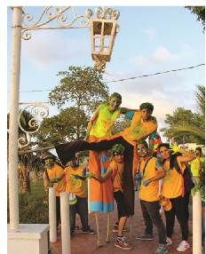

LIST OF BULLETINS

- Boletín Enero – Diciembre de 2013 Observatorio Local de la Violencia del Distrito Central (Edición N° 11, marzo 2014).
- Boletín Enero – Diciembre de 2013. Observatorio Local de la Violencia de La Ceiba (Edición N° 11, Marzo 2014).
- Boletín Enero – Diciembre de 2013 Observatorio Local de la Violencia de San Pedro Sula (Edición N° 7, Abril 2014).
- Boletín Enero – Diciembre de 2013. Boletín Especial sobre Homicidios Múltiples (Edición especial N° 18, Abril 2014).
- Boletín Enero – Diciembre de 2013. Observatorio Local de la Violencia de Tela (Edición N° 2, Mayo 2014).
- Boletín Enero – Diciembre de 2013. Observatorio Local de la Violencia de Choloma (Edición N° 11, Mayo 2014).
- Boletín Enero – Diciembre de 2013. Observatorio de la Violencia Mortalidad y Otros (Edición N° 32, Febrero 2014).
- Boletín Enero 2010 – Mayo 2014. Boletín Especial sobre Homicidios de Estudiantes (Edición Especial N° 21, junio del 2014).
- Boletín Enero – Junio de 2013. Observatorio Local de la Violencia de San Pedro Sula (Edición N° 5, Mayo 2014).
- Boletín Enero – Junio de 2014. Observatorio Local de la Violencia de La Ceiba (Edición N° 13, Septiembre 2014).
- Boletín Enero – Junio de 2014. Observatorio Local de la Violencia de Tela (Edición N° 3, Septiembre 2014).
- Boletín Enero – Junio 2014. Observatorio de la Violencia Mortalidad y Otros (Edición N° 34, Septiembre 2014).
- Boletín Enero – Junio de 2014. Observatorio Local de la Violencia de Choloma (Edición N° 12, Septiembre 2014).

Contents, Sub-Topics, and Responsible Partners in the Informal Training for Municipal Officials

Content | Sub-topics | Responsibles
Human Security, Citizen Security, and Development | - Concept and dimensions of human security  - Public security vs citizen security  - Human development | UNDP, Municipal Planning Component, NDI
Definition and classification of violence | - Concept and classification  - Violence as a public health problema  - Model for understanding violence  - Challenges in mediation, intervention and evaluation | UNDP, Municipal Planning Component
Sex, gender, and violence | - Concept and difference between sex and gender  - Masculinity  - Violence against women: Violencia contra las mujeres: interpersonal injuries (physical violence, sexual violence) and mortality (femicides) | UN Women
Coexistence and civic culture | - Human rights, citizen obligations and responsibilities  - Coexistence in public and private spheres  - Coexistence and security  - Civic Culture: Cultura ciudadana: adherence to law, compliance, public policies | UNDP, Cultural Component  IMPACTOS Program
Theories of behavior in health | - Communication in health promotion and prevention  - Theories of behavior (individual and community) | UNDP, Communications and Municipal Planning Components
Organizational Development and Citizen Security | - Concept of Organizational Development  - Institutional Strengthening for citizen security  - Challenges in citizen security management | IMPACTOS Program  AMHON

Catacamas, Choloma, Choluteca, Comayagua, Danlí, El Paraíso, El Progreso, Gracias, Juticalpa, La Ceiba, La Lima, Nacaome, Omoa, Puerto Cortés, San Lorenzo, San Manuel, San Pedro Sula, Santa Cruz de Yojo, Santa Rosa de Copán, Siguatepeque, Tela, Tocoa, Trujillo, Villanueva, and Yuscarán.
2 See Statistics Tables in Annexes
See Annex: List of Bulletins
See Annex: Table of Contents, sub-topics, and people responsable in the informal training of municipal officials
This activity was conducted by a direct request to the council members during the first seminar to prepare the 2014 AOP.
Report of the Environmental Mitigation Plan for Opening Community Coexistence Places in the five target municipalities
Exchange rate as of September 2014 according to the UNDP System: $ 1= Lps 21.2254

